**PRICE THEORY**

Price theory is a microeconomics principle that involves the analysis of demand and supply in determining an appropriate price point for a good or service.

This section is concerned with the study of prices and it forms the basis of economic theory.

**PRICE DEFINITION**

Price is the exchange value of a commodity expressed in monetary terms.

**OR**

Price is the monetary value of a good or service.

For example the price of a mobile phone may be shs. 84,000/=.

**PRICE DETERMINATION**

Prices can be determined in different ways and these include;

1. **Bargaining/ haggling.**

This involves the buyer negotiating with the seller until they reach an agreeable price. The seller starts with a higher price and the buyer starts with a lower price. During bargaining, the seller keeps on reducing the price and the buyer keeps on increasing until they agree on the same price.

1. **Auctioning/ bidding**

This involves prospective buyers competing to buy a commodity through offering bids. The commodity is usually taken by the highest bidder.

This method is common in fundraising especially in churches, disposal of public and company assets and sell of articles that sellers deem are treasured by the public.

Note that the price arising out of an auction does not reflect the true value of the commodity.

1. **Market forces of demand and supply.**

In this case, the price is determined at the point of intersection of the market forces of demand and supply. This is common in a free enterprise economy. The price set is called the equilibrium price.

1. **Fixing price by treaty/ agreement.**

This involves the buyer sitting with the seller to negotiate and fix the price at which a good or service shall be sold and the price remains fixed. The price agreed upon at the time of signing the agreement can be changed or revived by amending the treaty. For example hire purchase and deferred payments agreement, rental agreements, land purchase agreements

1. **Price leadership**

This is the setting of price by either a leader firm or low cost firm in the industry and other firms follow by charging the same price. This form of price determination is common in oligopolistic firms.

Price leadership takes on the following forms;

* Dominant price leadership
* Barometric price leadership
* Aggressive or exploitative price leadership

1. **Price legislation/ control/ administration.**

This is where the government fixes prices of commodities that is either a maximum price to protect consumers or a minimum price to protect producers.

1. **Offers at fixed prices**

This is where individuals, government and institutions set the price at which a commodity is to be sold and whoever is to buy from them must pay the fixed price. For example UNEB fixes prices for its examinations, UMEME for a unit of electricity, NWSC for a litre of piped water, in super markets.

1. **Collusion.**

This involves sellers agreeing on the price to charge the buyers. It is common when there are few sellers who wish to reduce competition among them and avoid price wars.

For example different operators of bus services can collude or agree to charge a uniform transport fare from passengers on given routes along which their buses operate.

1. **Resale price maintenance.**

This is a mechanism of price determination where manufacturers set the prices at which their commodities are to be sold to the final consumers by retailers. The price is usually written on the commodity. In Uganda, resale price maintenance is practiced by;

* Post office on stamps
* The press industry on newspapers
* The telecommunication network industry on airtime cards, simpacks and phones on promotion.

**MERITS OF RESALE PRICE MAINTENACE**

1. Ensures price stability in the market.
2. Stabilises income and profits of retailers
3. Protects small retailers from being outcompeted by large scale retailers.
4. Saves time which would have been spent on bargaining.
5. Enables producers to easily calculate their revenue from sales.
6. Reduces consumer exploitation in form of increased prices by sellers/ retailers.
7. Facilitates the collection of taxes by government because prices are stable.
8. Enables consumers to make consumption plans/ budgets.

**CLASSIFICATION OF PRICE**

Price may be classified into;

1. **Market price**

This is the ruling/ prevailing price in the market at a particular time determined by buyers and sellers. This price changes from time to time since it is determined by a number of factors.

1. **Equilibrium price**

This is the price at which quantity demanded is equal to quantity supplied in the market.

The equilibrium quantity and price are got at the point of intersection of the demand and supply forces.

**Illustration**

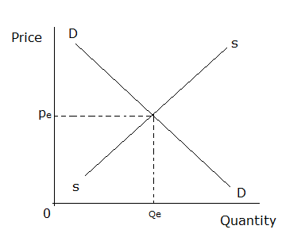

OPe is the equilibrium price.

1. **Normal price**

Is the price attained/ obtained when quantity demanded equals quantity supplied in the long run.

OR

This is the long run equilibrium price that persists in the market when supply and demand conditions have settled. It is an ideal price which may never be realized and the market price tends to oscillate around it.

1. **Reserve/ reservation price.**

Is the least/ minimum/ lowest price a producer/ seller is willing to accept in exchange of his/ her commodity below which he/ she retains the commodity.

**DETERMINANTS OF RESERVE PRICE**

1. **Expected future demand for a commodity.**

A producer who expects demand for his commodities to increase in the nearby future sets a high reserve price to retain many goods for sell in the future when demand increases while a producer who expects demand for his commodities to fall in the nearby future sets a low reserve price currently so as to sell off the commodity very fast before demand falls.

1. **Expected future price of the commodity.**

A seller who expects the future price of the commodity to increase sets a high reserve price so as to retain many goods for sell at a higher price in the future. However, sellers expecting reductions in future prices set low reserve prices such that they sell more currently and avoid the lower prices in the future.

1. **Nature of the commodity (perishable goods vs durable goods)**

A seller dealing in durable goods sets a high reserve price because his goods are long lasting and can remain in good condition even when not bought urgently. However, a seller who deals in perishable goods sets a low reserve price to sell off the goods before they go bad.

1. **Degree of necessity of the commodity.**

Sellers dealing in commodities with a high degree of necessity set high reserve prices because they know that consumers cannot do without them. However, sellers dealing in commodities with a low degree of necessity set low reserve prices because they know that consumers can do without them.

1. **Size of transport (carriage) and storage charges.**

High storage and transport charges lead to a low reserve price because the seller wishes to sell off the commodity very fast before incurring more of these charges. However, low transport and storage charges lead to a high reserve price because the seller is not scared of transporting or storing goods for a long period of time.

1. **The length of the gestation period**

A long gestation period leads to a high reserve price because the producer is aware of the inconveniences he/ she is going to go through to produce the next commodities. However, a short gestation period implies that the seller needs less time to produce the commodity and therefore he sets a low reserve price.

1. **Level of liquidity preference of the producer/seller.**

Sellers with urgent need for cash (high liquidity preference) set low reserve prices to ensure that they actually sell the goods for the money they need. However, sellers with no urgent need for cash (low liquidity preference) set high reserve prices.

1. **The cost of production.**

Producers who incur high costs of production set high reserve prices because it is expensive for them to replace the sold goods. However, producers who incur low costs of production set low reserve prices because it is cheap for them to replace the sold goods.

**NB**

1. Gestation period is the time it takes before new supplies of goods reaches the market for example maize takes 3-4 months while mushrooms take 1 month.
2. Liquidity preference (demand for money) is the desire by individuals to hold assets/ wealth in cash form or near cash form (rather than investing it).

ASSIGNMENT

Explain the factors that lead to high reserve price.

**FACTORS THAT INFLUENCE PRICING OF GOODS AND SERVICES**

1. **Forces of demand and supply.**

As supply exceeds demand, low prices are set due to a surplus of commodities on the market. However when demand exceeds supply, high prices are set for commodities because they are scarce.

1. **Aim/ objective of the producer.**

Where producers aim at profit maximization, they restrict output charge a high price and where producers aim at sales maximization, they charge relatively lower prices to encourage people to buy as much quantities as possible.

1. **Cost of production.**

High cost of production leads to a high price set since producers aim at profit maximization and low cost of production leads to a low price set for the commodity.

1. **Rate of taxation.**

Heavy taxes imposed on goods and services lead to high prices set since producers tend to shift the burden of paying taxes to consumers in form of increased prices. However, low taxes imposed on goods and services lead to low prices set.

1. **Quality of the commodity.**

High quality goods are highly priced since producers incur high costs in producing them while low quality goods are lowly priced as they are cheap to produce.

1. **Elasticity of demand for a commodity.**

Producers set high prices for commodities whose demand is price inelastic since people continue to buy even if prices increase and they set low prices for those whose demand is price elastic since any slight increase in price results a big fall in quantity demanded.

**USES OF PRICE IN A MARKET ECONOMY**

* It is used to determine what to produce.
* It is used to determine how to produce.
* It is used to determine where to produce.
* It is used to determine for whom to produce
* It is used to determine when to produce.
* It is used to determined how much to produce.
* It is used to determine the value of a good.

**THE MARKET CONCEPT**

A market is a mechanism in which buyers and sellers come into contact and exchange goods and services.

A market where goods and services are traded is known as a **commodity market.**

**FEATURES OF A MARKET**

* There should be sellers
* There should be buyers
* There should be an interaction between sellers and buyers.
* There should be a commodity to be exchanged.
* There should be an established medium of exchange.

**DEMAND THEORY**

**DEFINITIONS**

**Demand** is the desire backed by the ability to pay a given amount of money for a particular amount of a commodity in a given period of time.

**OR**

**Demand** is the amount of a good that a consumer is willing and able to buy at a given price in a given period of time.

**Market demand** is the total demand for a commodity in the market by all consumers at a given price in a given period of time.

**Effective demand** is the actual buying of goods and services at a given time.

**TYPES OF DEMAND**

1. **Joint/ complementary demand.**

This is the demand for commodities which are used together; an increase in the demand for one commodity leads to an increase in the demand for the other commodity.

Examples of joint demand include;

* Demand for cars and fuel
* Demand for books and pens
* Demand for DVD players and DVDs.
* Demand for guns and bullets
* Demand for cameras and films
* Etc

1. **Competitive demand.**

This is the demand for commodities which serve the same purpose; an increase in the demand for one commodity leads to a decrease in the demand for the other commodity.

Examples of competitive demand include;

* Demand for butter and honey
* Demand for bread and cakes
* Demand for tea and coffee
* Demand for Omo and Nomi
* Demand for close up and fresh up
* Demand for beans and peas
* Etc

1. **Independent demand.**

This refers to demand for commodities which are not related such that the demand for one commodity does not directly affect the demand for another commodity.

Examples of independent demand include;

* Demand for clothes and food
* Demand for a car and a pen
* Etc

1. **Composite demand**

This is the total demand for a commodity which has several/ many uses.

Examples of composite demand include;

* Demand for electricity (for lighting, ironing, cooking, etc)
* Demand for water (for cooking, bathing, etc)
* Demand for timber (for construction, furniture making, manufacturing, etc)
* Demand for cotton wool (for cloth making, cushioning, cleaning, etc)
* Demand for steel (for manufacturing machines, motor cars, roofing, etc)
* Demand for clay (for making pots, bricks, cups, etc)
* Demand for an axe (for splitting wood, tool of defence, etc)
* Demand for skins and hides (for making shoes, bags, belts, etc)
* Demand for paper (for making books, bank notes, envelopes, toilet paper, etc)
* Demand for cloth (for adornment, protection, etc)
* Etc.

1. **Derived demand.**

This is the demand for a commodity not for its own sake but for the sake of what it helps to produce.

OR

It is the demand for a commodity due to the demand for the commodity that it helps to produce.

Examples of derived demand include;

* Demand for land
* Demand for labour
* Demand for capital
* Demand for entrepreneurship
* Demand for organisation.

**ASSIGNMENT**

1. a) What is composite demand? (01 mark)

b) State any three examples of commodities with composite demand in your country.

(03 marks)

**THE DEMAND SCHEDULE**

This is a table showing the amount of a commodity demanded at various prices by a consumer or groups of consumers during a particular period of time. This schedule can be compiled either for an individual or for all individuals in the market.

**INDIVIDUAL AND MARKET DEMAND SCHEDULES**

|  |  |  |  |
| --- | --- | --- | --- |
| Price  (in Shs. Per kg) | Quantity demanded  By Consumer A | Quantity demanded by Consumer B | Market demand  (in kg) |
| 5,000 | 40 | 20 | 60 |
| 4,000 | 60 | 40 | 100 |
| 3,000 | 80 | 60 | 140 |
| 2,000 | 100 | 80 | 180 |
| 1,000 | 120 | 100 | 220 |

The market demand schedule is derived by horizontal summation of the quantities purchased at each price by all the individuals / consumers in the market. The quantities in the market schedule are larger than those of the individuals demand schedule.

One major characteristic of a demand schedule is that the higher the price the lower the quantity demanded and the lower the price the higher the quantity demanded of the commodity in question other factors being constant.

The information tabulated in a demand schedule can be summarized or represented graphically on a curve

**THE DEMAND CURVE**

The demand curve is a graphical representation of the demand schedule.

The demand curve is a locus of points showing the quantities demanded of a commodity at various prices in a given period of time.

Price is represented on the vertical axis while quantity demanded is on the horizontal axis.

From the above table, an individual demand curve (Consumer A) can be drawn as shown below.

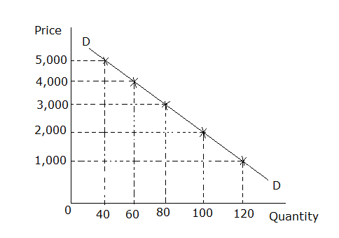

A normal demand curve is downward sloping from left to right, that is it has a negative slope meaning that there is an inverse relationship between price and quantity demanded. (As the price increases, quantity demanded decreases and vice versa).

**QUALITIES OF A NORMAL DEMAND CURVE**

1. It must be downward sloping from left to right.
2. It should not touch either of the axes. If it touches the Y-axis, it implies that a consumer incurs a cost for a commodity which has not been obtained. (He pays a price at zero quantity). If it touches the X-axis, it implies that the consumer is buying a commodity at zero prices.

**THE LAW OF DEMAND**

The law of demand states that “the higher the price of a commodity, the lower the quantity demanded and the lower the price of a commodity, the higher the quantity demanded holding other factors constant (Ceteris paribus).

**REASONS WHY THE DEMAND CURVE SLOPES DOWNWARDS FROM LEFT TO RIGHT (EXPLAINING THE LAW OF DEMAND)**

A normal demand curve is one that slopes downwards from left to right following the law of demand. The following reasons explain why the demand curve slopes downwards from left to right.

1. **The law of diminishing marginal utility**

According to this law, when a consumer buys more units of the commodity, the marginal utility of that commodity continues to decline; and therefore the consumer will buy more units of the commodity only when the price reduces. When fewer units are available, utility will be high and the consumer will be prepared to pay more for that commodity. This proves that demand will be low at a higher price and that is why the demand curve is downward sloping.

1. **The substitution effect of a price change.**

When the price of the commodity falls, the price of substitutes remaining the same, a consumer reduces the quantities of other substitute goods whose prices now appear relatively high and increases the quantity of the commodity whose price has fallen. When the price of the commodity under consideration increases, the consumer leaves the commodity and buys the substitutes, given constant prices of substitutes hence the downward sloping demand curve.

1. **The income effect of a price change. (Real income effect)**

When an individual has a fixed income and the price of the commodity reduces, his real income increases and hence he can buy more units of the commodity with his fixed income. On the other hand when the price increases, the consumer’s real income decreases and hence he buys less units of the commodity hence the downward sloping demand curve.

1. **The total effect of a price change.**

This is the combination of the substitution and income effects. When the price of the commodity falls, the quantity demanded increases because many new buyers are attracted while an increase in price leads to a decrease in demand because it scares away buyers hence the inverse relationship between price and quantity demanded which produces a downward sloping demand curve.

1. **Behaviour/presence of low income earners.**

The demand curve depends upon the behaviour of low income earners. They buy more when price reduces and less when the price increases. This leads to a downward sloping demand curve. (The rich do not have effect on the demand curve because they are capable of buying the same quantity even at a higher price)

1. **Different/various uses of certain commodities.**

Some goods have more than one use e.g. water, electricity, etc such that when the price of the commodity increases, consumers tend to use it for essential purposes only hence reducing on its demand. On the other hand when the price reduces, the consumers put the commodity to many uses thereby increasing quantity demanded hence a downward sloping curve.

**DETERMINANTS/ FACTORS INFLUENCING/ AFFECTING DEMAND.**

1. **Price of the commodity in question.**

A high price leads to low demand because it scares away some buyers. However, a low price attracts new buyers hence high commodity demand.

1. **Price of substitutes.**

A high price of substitutes leads to high commodity demand because the commodity appears relatively cheaper. On the other hand, a low price of substitutes leads to low commodity demand because the commodity appears to be relatively expensive.

1. **Price of complements.**

A high price of a complement leads to low commodity demand because it is expensive to use both goods together. On the other hand a low price of a complement leads to high commodity demand because it is cheap to use both goods together.

1. **Level of consumer’s income.**

High level of consumer’s income leads to high purchasing power hence high commodity demand. However, low level of consumer’s income leads to low purchasing power hence low commodity demand.

1. **Tastes and preferences of consumers.**

Favourable tastes and preferences result in high commodity demand because they are able to raise the consumer’s interest in the commodity. However, unfavorable tastes and preferences result into low commodity demand because they make the consumer to develop bias against the commodity.

1. **Population size.**

A large population size creates high commodity demand because it is associated with many buyers. However, a small population size leads to low commodity demand because it has few buyers.

1. **Nature of income distribution.**

A fair distribution of income leads to high commodity demand because many people can afford to purchase a commodity. However, high level of income inequality between individuals and different groups of people leads to low commodity demand because there are few people who can afford to purchase the commodity.

1. **Future price expectation.**

Expectation of a high price in the nearby future leads to high commodity demand currently because buyers stock more goods to avoid the higher prices in the future. However, expectation of a low price in the nearby future leads to low commodity demand currently because the buyer reserve some money so as to buy more when the price falls.

1. **Government policy on taxation.**

High level of direct taxation leads to low commodity demand because people have low disposable income while low level of direct taxation leads to high commodity demand because people have high disposable income.

1. **Seasonal factors.**

Certain commodities are demanded in particular seasons. Favourable season leads to high commodity demand and unfavourable season leads to low commodity demand. It is common to see vendors selling success cards during examination periods, Christmas cards in Christmas period and Easter cards in the Easter period. However outside those periods, one can hardly find them on the market because no one is willing to purchase them.

1. **Level of advertising.**

A high level of advertising leads to high commodity demand because it results into high level of awareness of the consumers about the availability of the commodity. On the other hand, low level of advertising leads to low commodity demand because it leads to low level of awareness of the consumers about the availability of the commodity.

1. **The prevailing economic conditions in an economy.**

Commodity demand tends to be high during periods of economic prosperity (boom) because during such times, people are employed and earn fair income to purchase the commodity. However, commodity demand is low during periods of economic depression because many people have no jobs and thus have no income to purchase the commodity.

1. **Quality of the commodity.**

A high quality of the commodity encourages people to buy hence high commodity demand while a low quality of the commodity forces people to abandon it hence low commodity demand.

1. **Availability of credit facilities.**

Commodity demand is high when consumers are allowed to take goods on credit because many consumers without immediate cash are able to buy the commodity. However, commodity demand is low when consumers are not allowed to buy goods on credit because the few buyers with cash are the only ones who buy.

1. **The law of diminishing marginal utility.**

With high marginal utility, commodity demand is high because the commodity is highly enjoyable and satisfying to the buyer. However at low marginal utility, commodity demand is low because the commodity is less enjoyable and satisfying to the buyer.

1. **Socio-economic factors.**

These include age, sex, religion, culture etc. One or a combination of these factors to some extent influence demand for a commodity. For instance demand for pork is low in places where there are many Muslims as compared to places where there are many Christians especially Catholics and Pentecostals.

ASSIGNMENT

1. Explain the factors that lead to high demand of a commodity.
2. Explain the factors that lead to low demand of a commodity.

**SHIFTS IN DEMAND**

These involve change in demand and change in quantity demanded.

**CHANGE IN DEMAND**

A change in demand refers to an economic situation where more or less units of a commodity are demanded at a constant price brought about by a change in other factors affecting demand for that particular commodity.

It is illustrated by a total shift of the demand curve either inwards to the left or outwards to the right holding the commodity price constant.

Illustration

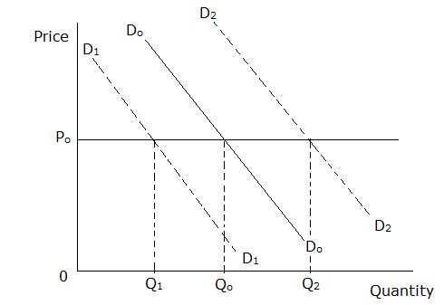

From the above illustration, DODO is the original demand curve.

D1D1 shows a shift of the demand curve inwards from DODO representing a decrease in demand.

D2D2 shows a shift of the demand curve outwards from DoDo representing an increase in demand.

**QUESTION**

Explain the factors that cause a change in demand for a commodity.

Solution

**NOTE**

1. The factors that cause a change in demand are generated from the determinants of demand other than the commodity’s own price.
2. Words that can be used when stating the point include;

* Change
* Variations
* Instabilities.

1. Avoid words like high/ low in your explanation. Use words like increase, rise, decrease, decline, fall, etc.
2. A change in prices of substitutes.
3. A change in prices of complements.
4. A change in the level of consumer’s income
5. A change in the population size
6. Expectation of a future change in the price of the commodity.
7. A change in government policy of taxation and subsidization.
8. A change in the level of advertisement.
9. A change in seasons.
10. A change in tastes and preferences
11. A change in the quality of the commodity
12. A change in the economic conditions.
13. A change in the nature of distribution of income.

**INCREASE IN DEMAND**

This is the demand for more quantities of a commodity due to conditions of demand/ factors that influence demand becoming (more) favourable while holding price of the commodity (in question) constant.

It is represented by a total shift of the demand curve outwards to the right holding the commodity price constant.

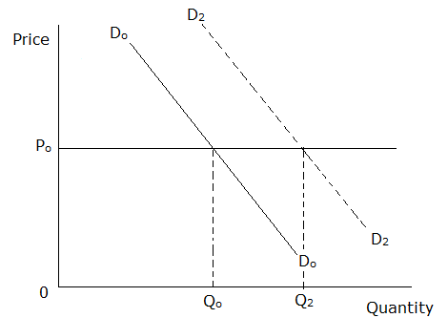

**ASSIGNMENT**

Explain the factors that lead to an increase in demand for a commodity in your country.

(20 marks)

**DECREASE IN DEMAND**

This refers to a decline in quantity demanded of a commodity due to factors that influence demand becoming unfavourable while holding price of the commodity (in question) constant.

It is represented by a total shift of the demand curve inwards to the left holding the commodity price constant.

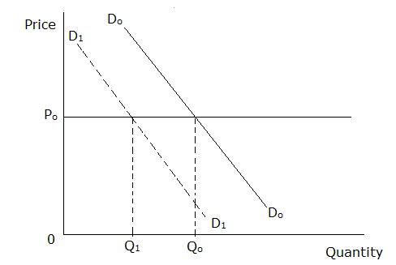

**ASSIGNMENT**

Account for a decrease in commodity demand in your country (20 marks)

**CHANGE IN QUANTITY DEMANDED**

This is an economic situation where more or less units of a commodity are demanded due to change in its price when other factors affecting demand for that particular commodity have not changed.

**OR**

A change in quantity demanded refers to a rise or fall in the amount of a commodity demanded due to changes in price levels of a commodity assuming other determinants of demand are held constant.

It is illustrated by the movement along the demand curve either upward due to price increase or downward due to price fall.

Illustration

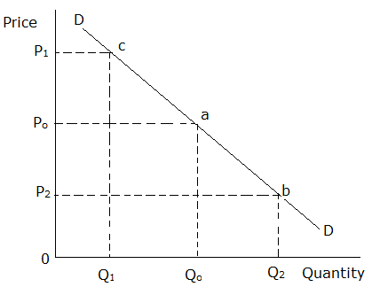

A fall in price from OPo to OP2 leads to an increase in quantity demanded from OQo to OQ2 as illustrated by the movement along the demand curve downwards from point a tob.

A rise in price from OPo to OP1 leads to a decrease in quantity demanded from OQoto OQ1as illustrated by the movement along the demand curve upwards from point a toc.

**INCREASE IN QUANTITY DEMANDED**

This refers to the demand for more units of a commodity due to a fall in its price while holding other factors constant/ ceteris paribus.

Illustration

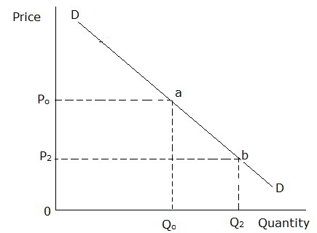

**DECREASE IN QUANTITY DEMANDED**

This refers to the demand for lesser quantity of a commodity due to increase in its price ceteris paribus.

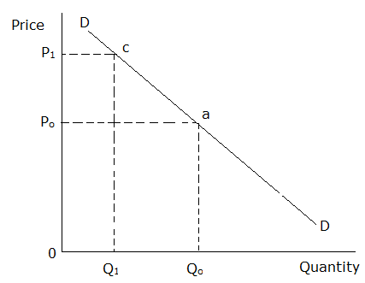

**ABNORMAL/ REGRESSIVE/ EXCEPTIONAL DEMAND CURVES**

These are curves which do not obey the law of demand.

Such curves take a different shape from the one of the normal demand curve.

The following are the factors that violet the law of demand.

1. **Demand for articles of ostentation/ luxuries/ conspicuous consumption.**

These are goods bought by the rich people to impress or attract the attention of others for example sports cars, golden earrings. More of such goods are demanded at a higher price than at a lower price. The demand curve for luxuries is regressive at the upper level.

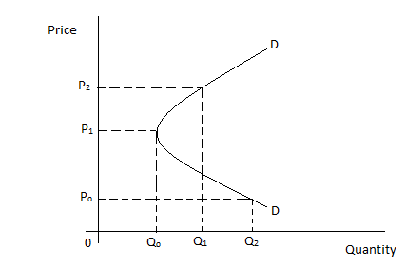

The quantity demanded is very high at a low price. As the price increases to an average price, the quantity demanded reduces so much because many poor people can no longer afford. As the price increases further to a very high price, the quantity demanded increases because all the rich people start buying the commodity.

1. **Demand for giffen goods.**

These are inferior goods which take a large proportion of the budget of low-income earners such that when their prices increase, the consumer reduces the consumption of other goods and buys the giffen good. Examples of giffen goods are the basic foodstuffs such as rice, maize, bananas and cassava.

For these giffen goods, the demand curve is regressive at the lower level such that if prices over increase, consumers have to lower the demand altogether.

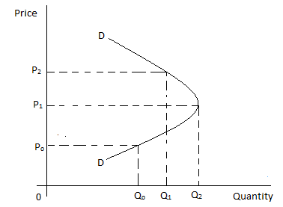

An increase in the price from OPo to OP1 causes an increase in amount demanded i.e. from OQoto OQ2.

1. **Demand for necessities.**

Goods which are very essential tend to have a fixed demand at different price levels. E.g. salt.

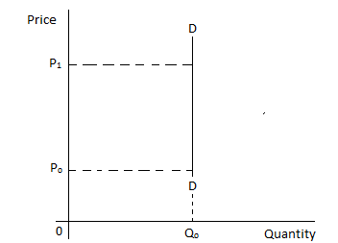

1. **Speculation (future price expectations)**

There are cases when people buy more as prices rise because they expect them to rise even further in future and less as prices fall because they expect them to fall even further. Such behaviour is known as speculation and it’s common in stock exchange, real estate, etc. This creates a positive relationship between price and quantity demanded.

1. **Ignorance effect.**

Some consumers may buy more units of the commodity at high prices due to information asymmetry/ market imperfection. Some also buy the more expensive item because they believe it to be of better quality.

1. **Effect of an economic boom or depression.**

In times of a depression, fewer quantities of goods are purchased even when their prices are reduced because purchasing power is very low. In times of an economic boom, more quantities of goods are purchased even when their prices are increased because purchasing power is very high. In both cases, the demand curve is positively sloped.

1. **Addiction to the consumption of the commodity.**

Consumers who are addicted to consumption of particular commodities normally buy the same quantities of the good even if the price increases e.g. smokers.

1. **Special seasons.**

The demand for some goods depends on seasons. A favourable change in seasons for the commodity leads to an increase in commodity demand even if the prices are increasing hence violating the law of demand.

**Assignment**

1. Define the term **market demand.**
2. State the determinants of market demand in an economy.

**ENGEL CURVE**

This is a curve that describes how household expenditure on a particular good or service varies with household income. It was named after the German statistician Ernst Engel (1821 – 1896) who was the first to systematically investigate the relationship between demand and income of the consumer in 1857.

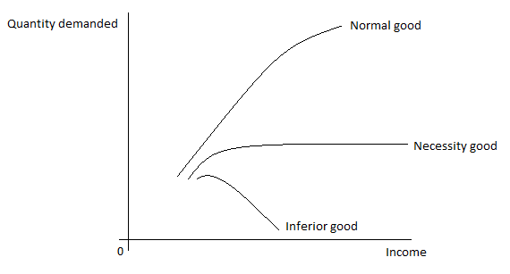

From the diagram above, the following can be observed.

1. For normal goods, the Engel curve has a positive gradient. That is as income increases, the quantity demanded also increases. Conclusively, normal goods have a positive income elasticity of demand
2. For inferior goods, the Engel curve has a negative gradient. That means that as the consumer’s income increases, fewer amounts of the inferior good are bought because they are capable of purchasing better goods. Conclusively, inferior goods have a negative income elasticity of demand.
3. For necessity goods, as the consumer’s income increases, the amount demanded increases slightly and then becomes constant. Conclusively, necessity goods have zero income elasticity of demand.

**REASONS WHY PEOPLE DEMAND FOR GOODS**

1. **For functional reasons/ to create utility.**

Some people buy goods to use them to satisfy their needs. A commodity is demanded because of its function or use. For example one buys a bottle of water to quench thirst.

1. **Impulsive effect.**

This is the demand for a good after seeing it. For example as a hawker is moving around, some people may develop the idea of buying a product because they have seen it.

1. **Speculative demand/ effect.**

Some people buy more of certain goods hoping that they might become scarce in the future. Others buy goods hoping to make gains by buying at a lower price and selling them at a higher price in the future.

1. **Snob effect/ conspicuous consumption.**

This is the demand for a good in order to impress the public or to show off. In this case, the good is demanded highly when its price is high. The consumption of expensive commodities in order to show off is referred to as conspicuous consumption.

1. **Veblen effect/ exclusivity.**

This is the demand for a good in order to look unique or look different from others.

1. **Band wagon effect/ inclusivity.**

This is the demand for a good so as to like others. Some people buy goods because they have seen others using them.

1. **For purposes of producing other goods.**

Some people buy capital goods for use in the production of other goods.

1. **For complementary reasons.**

Some people buy goods because they want to make other goods in their possession useful or operational e.g. one buys fuel to make a car useful.

**THE THEORY OF CONSUMERS’ BEHAVIOURS**

A consumer is an individual who buys products or services for personal use and not for manufacture or resale.

A consumer is always faced with a problem of allocating a fixed income among a variety of available options.

A consumer is assumed to be rational i.e. given his income and the market prices of the various commodities; he plans the spending of his income so as to attain the highest possible utility.

**DEFINITION OF CONCEPTS**

1. Utility

This is the satisfaction derived from consuming a certain amount of a good or service.

OR

Utility is the ability of a commodity to give satisfaction for example water has utility because it can quench your thirst.

Utility can be measured in monetary units by the amount of money a consumer is willing to sacrifice for a given amount of a commodity.

1. Total utility

This refers to the total satisfaction obtained from the consumption of all possible units of a commodity.

1. Marginal utility

This is the additional satisfaction derived from consuming an extra unit of a commodity.

Marginal utility is calculated as follows.

$$Marginal utility=\frac{Change in Total Utility}{Change in number of units}$$

$$MU=\frac{∆TU}{∆Q}$$

The concepts of total utility and marginal utility can be better understood from the following schedule and diagram.

|  |  |  |
| --- | --- | --- |
| Units consumed | Total Utility | Marginal Utility |
| 0 | 0 | $$-$$ |
| 1 | 20 | 20 |
| 2 | 37 | 17 |
| 3 | 47 | 10 |
| 4 | 52 | 5 |
| 5 | 52 | 0 |
| 6 | 47 | $$-5$$ |
| 7 | 35 | $$-12$$ |

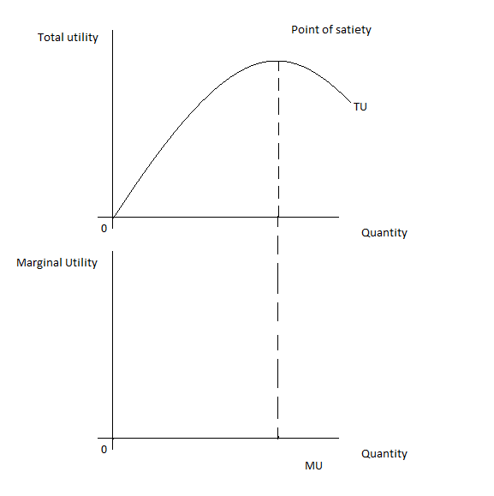

From the schedule and the diagram above, we note the following;

* As total utility is increasing, marginal utility is falling but positive.
* When total utility is at its maximum (point of satiety), marginal utility is zero.
* When total utility is decreasing, marginal utility becomes negative and this shows disutility.

1. Disutility

This is the loss of satisfaction due to consumption of so many units of a commodity.

**THE LAW OF DIMINISHING MARGINAL UTILITY**

It is states that as more and more units of a commodity are consumed in succession, the satisfaction derived from each additional unit consumed reduces.

**ASSUMPTIONS UNDERLYING THE LAW OF DIMINISHING MARGINAL UTILTIY**

* It assumes that the consumer aims at utility maximization.
* The consumer has a fixed level of income.
* The commodity prices are fixed and constant.
* The consumer has perfect knowledge about the prevailing market conditions.
* The consumer’s tastes and preferences and preferences are constant.
* It assumes consumption of only one commodity whose units are homogeneous.
* It assumes that the commodity has uniform sizes i.e. the commodity is divisible into similar portions.
* It assumes continuity in consumption i.e. the units of the commodity should be consumed in succession one after the other.
* It assumes that the consumer does not develop addiction to the commodity.
* It assumes that utility is measurable in monetary units (utils).
* It assumes that the commodity consumed is a normal good.

**RELATIONSHIP BETWEEN MARGINAL UTILITY AND THE DEMAND CURVE**

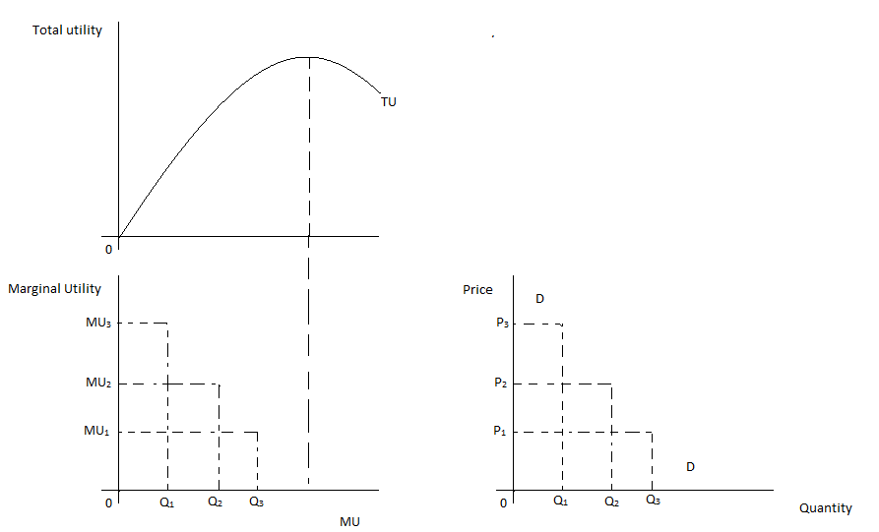

The derivation of the demand curve is based on the law diminishing marginal utility. Marginal utility is the slope of the total utility curve.

As marginal utility declines, the consumer is willing to pay less for the commodity. The consumer can buy more if the price is reduced since marginal utility is low.

When fewer units of the commodity are available, marginal utility is high and the consumer is willing to pay high prices for the commodity. This implies that demand is more at lower prices and less at high prices.

If marginal utility is measured in monetary units, then the demand curve for the commodity is identical to the positive segment of the marginal utility curve.

**Sample questions**

1. Distinguish between **price** and **marginal utility.** (02 marks)
2. What is the relationship between marginal utility and price? (02 marks)
3. With the help of illustrations, show the relationship between marginal utility and demand.

Solution

1. Refer to your notes
2. As marginal utility declines, the consumer is willing to pay less for the commodity. The consumer can buy more if the price is reduced since marginal utility is low.
3. Both are high for the first unit of output consumed and they tend to fall as more and more of a product is consumed.

Both are illustrated by a downward sloping curve. **(2 marks)**

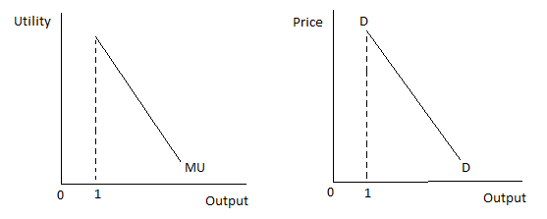

**@1 mark**

**APPLICABILITY OF THE LAW OF DIMINISHING MARGINAL UTILITY**

1. It helps to explain the law of demand.
2. It is applied under the principle of progressive taxation.
3. The law is used to explain the water – diamond paradox.
4. It explains why discounts are offered on extra units purchased.
5. Guides consumers when making consumption decisions.
6. It guides in pricing of goods and services.

**LIMITATIONS/ CRICISIMS/ DEFECTS OF THE LAW OF DIMINISHING MARGINAL UTILITY**

1. It assumes that consumers are rational which is not always the case. Many consumers do not attach cardinal values on commodities being consumed.
2. It assumes that the units of the commodity consumed are homogeneous which is unrealistic. Units of the same commodity may be different e.g. when consuming a sugarcane.
3. It assumes constant tastes and preferences yet for the same individual; tastes and preferences keep on changing from time to time depending on the environment, age, fashion, etc.
4. Consumption is not always continuous i.e. the consumers take breaks when consuming commodities.
5. It assumes that commodities are divisible into standard sizes but this does not apply to all commodities e.g. furniture, vehicles, etc.
6. The law is not applicable to money because the more money one gets, the more marginal utility he/she gets.
7. It is not applicable under habitual consumption where marginal utility increases as the consumer consumes more of the commodity.
8. It is not applicable in situations where the commodity prices keep on changing due to inflation.
9. The assumption that the consumer’s income is fixed is unrealistic.
10. Utility cannot be measured as the law assumes i.e. there is no instrument which can be used to measure utility.
11. The law is not applicable in situations of joint demand where two commodities are consumed at the same time. This is because it assumes consumption of only one commodity at a time.
12. In most cases, the consumers are ignorant about the market prices of commodities. This violates the assumption of perfect knowledge of the consumer about the market price.

**CONSUMER’S SURPLUS**

This is the difference in monetary units between what the consumer is willing to pay for a commodity and what he actually pays.

**OR**

It is the additional utility which the consumer enjoys without paying for it.

Illustration

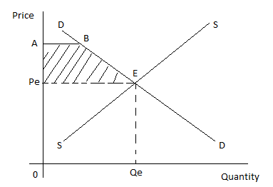

Consumer’s surplus is represented by the shaded region (Area under the demand curve but above the equilibrium price) i.e. Area PeABE.

It can be computed using the formula;

$$Consumer's surplus=Planned expenditure-Actual expenditure$$

Example

Study the table below showing the price and quantity purchased of commodity X and answer the questions that follow.

|  |  |
| --- | --- |
| Price consumers are willing to pay (shs) | Units purchased |
| 300  250  200  150  100  50 | 1  2  3  4  5  6 |

Calculate the consumer’s surplus if 4 units of the commodity were purchased at shs 150.

Solution

$$Consumer^{'}s surplus=Planned expenditure-Actual expenditure$$

$$=shs(\left(300+250+200+150\right)-\left(150×4\right))$$

$$=shs\left(900-600\right)$$

$$=shs 300$$

ALT

$$Consumer^{'}s surplus=Planned expenditure-Actual expenditure$$

$$300-150=150$$

$$250-150=100$$

$$200-150=50$$

$$150-150=0$$

$$=shs 300$$

Exercise

1. What is consumer’s surplus? (01 mark)
2. Given the table below;

|  |  |
| --- | --- |
| Price consumers are willing to pay (shs) | Units purchased |
| 9,000  8,000  7,000  6,000  5,000  4,000  3,000  2,000 | 1  2  3  4  5  6  7  8 |

Calculate the consumer’s surplus for the first five units of the commodity purchased.

(03 marks)

**PRODUCER’S SURPLUS**

This is the difference between the actual revenue a seller gets and the revenue he expected.

Illustration

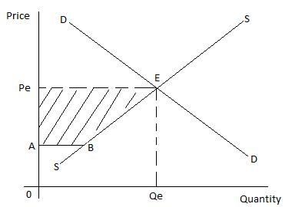

The producer’s surplus is represented by the shaded area (Area above the supply curve but below the equilibrium price) i.e. Area. APeEB.

It can be computed using the formula;

$$Producer^{'}surplus=Actual revenue-Expected revenue$$

Example

Given the supply schedule below;

|  |  |  |  |  |  |  |
| --- | --- | --- | --- | --- | --- | --- |
| Price(shs) | 50 | 60 | 80 | 100 | 140 | 200 |
| Quantity supplied | 1 | 2 | 3 | 4 | 5 | 6 |

Taking 100 to be the equilibrium price, calculate the producer’s surplus.

Solution

$$Producer^{'}surplus=Actual revenue-Expected revenue$$

$$=shs(\left(100×4\right)-(50+60+80+100)$$

$$=shs\left(400-290\right)$$

$$=shs 110$$

Exercise

1. Distinguish between producer’s surplus and consumer’s surplus. (02 marks)
2. Given that the market price of the commodity is Uganda shs 65,000; calculate the producer’s surplus in the table below.

|  |  |  |  |  |  |  |  |  |
| --- | --- | --- | --- | --- | --- | --- | --- | --- |
| Price (Ugx) | 30,000 | 35,000 | 40,000 | 45,000 | 50,000 | 55,000 | 60,000 | 65,000 |
| Supply | 1 | 2 | 3 | 4 | 5 | 6 | 7 | 8 |

(02 marks)

**SUPPLY THEORY**

**Supply** is the amount of a good or service that a firm is willing and able to offer for sale at a given price per period of time.

**Market supply** refers to the quantity of a good that all firms are willing to make available for sale at different prices in a given market during a given time.

**TYPES OF SUPPLY**

1. **Complementary (Joint) supply.**

Joint supply refers to the supply of two or more commodities from the same process of production/ same source/ same resources such that an increase in the supply of one commodity leads to increase in the supply of the other.

Examples of joint supply include;

* Supply of meat and skin from slaughtered animals/ beef and hides from slaughtered animals
* Supply of petrol, diesel and paraffin from crude oil (through factional distillation)
* Supply of mutton and wool
* Supply of maize flour and maize bran

1. **Competitive supply**

This refers to the supply of two or more commodities that use the same resources for their production such that an increase in the supply of one product leads to decline in the supply/ production of the other.

Examples of competitive supply include;

* Supply of eggs and meat from chicken
* Supply of milk and meat from cows
* Crop and animal production from a piece of land.
* Supply of jerry cans and basins from plastics.

**THE LAW OF SUPPLY**

The law of supply states that the higher the price, the higher the quantity supplied and the lower the price, the lower the quantity supplied ceteris paribus.

**THE SUPPLY SCHEDULE**

This is a table showing the number of units of a commodity sellers are willing to offer at alternative prices during a given period of time all other things being equal.

**ILLUSTRATION**

|  |  |
| --- | --- |
| Price in shillings | Quantity supplied in kg |
| 500 | 10 |
| 1000 | 20 |
| 1500 | 30 |
| 2000 | 40 |
| 2500 | 50 |

From the table above, it can be seen that as the price increases, quantity supplied also increases.

**THE SUPPLY CURVE**

The supply curve is the graphical representation of the supply schedule.

The supply curve is a locus of points showing the quantities supplied of a commodity at various prices in a given period of time.

From the above table, we derive the supply curve by plotting price against quantity supplied as shown below.

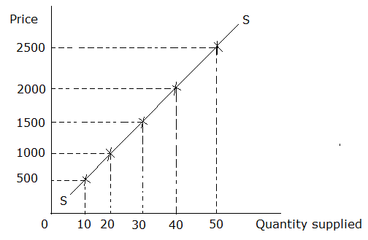

A normal supply curve is upward sloping from left to right, that is it has a positive slope meaning that there is a direct relationship between price and quantity supplied. (As price increases, quantity supplied increases and vice versa).

**ABNORMAL/ REGRESSIVE/ EXCEPTIONAL SUPPLY CURVES**

These are curves which do not obey the law of supply which states that the higher the price, the higher quantity supplied and the lower the price, the lower the quantity supplied ceteris paribus.

The following are the factors that violet the law of supply.

1. **Supply of labour.**

The supply curve for labour is as shown below.

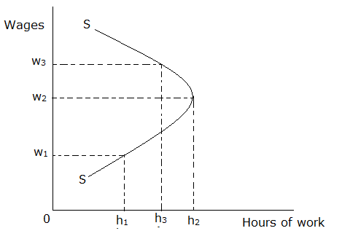

From the curve, when the wage increases from OW1to OW2, labour supply increases from Oh1 to Oh2. Further increase in wages from OW2to OW3leads to a reduction in labour supply from Oh2to Oh3. This is due to the following factors;

* Presence of target workers
* Preference of leisure to work
* Existence of a progressive tax system/ increased rate of taxation
* Cultural and political factors which influence reduction in labour supply (Discrimination in the employment sector)
* Declining working conditions
* Effect of old age
* Decline in the real wage of workers due to high levels of inflation

1. **Supply rigidities.**

At times the producers may not supply more even if the price of the commodity increases due to supply rigidities such as drought, political instabilities, etc. this causes a fixed supply.

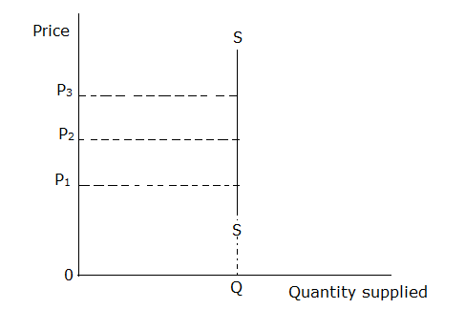

From the diagram above, same quantity is supplied at different prices until when the supply rigidities are removed.

1. **Supply of land.**

The supply of land cannot be increased. It is a fixed resource.



From the diagram, supply remains constant in spite of price changes.

1. **Expectation of future price changes (speculation)**

If producers expect the prices to increase in future, they put less on the market even if prices are slightly increasing. This is because they expect to get a lot of profits in future by selling at high prices. On the other hand, if the prices are expected to fall in the future, producers supply more even if the prices are slightly decreasing. This causes an abnormal supply curve.

1. **Supply of perishable goods**

For perishable goods, more is supplied immediately after harvest whether prices are high or low hence violating the law of supply.

1. **Exhaustion of raw materials.**

In this case, even if there is an increase in price, quantity supplied may not increase because the producers have no requirements to produce final goods.

1. **Existence of commodities supplied by the government.**

The government may decide to supply certain essential commodities to consumers at lower prices to improve peoples’ standards of living. This creates a regressive supply curve.

**FACTORS THAT INFLUENCE SUPPLY**

1. **Price of the commodity.**

A high price for the commodity in question leads to high supply because it attracts many producers to produce and maximise profits. However, a low price leads to low amount supplied because it discourages some producers from engaging in production.

1. **The price of a jointly supplied commodity.**

A high price for the jointly supplied product leads to high supply of the commodity in question because it becomes profitable to produce both goods while low price for a jointly supplied product leads to low supply of the commodity in question because it becomes unprofitable to supply both goods.

1. **The price of a competitively supplied product.**

A high price for competitively supplied good leads to low supply of the commodity in question because producers divert resources to production of other goods while a low price for competitively supplied good leads to high supply of the commodity in question because production of the commodity becomes profitable.

1. **The cost of production.**

At a high cost, the supply is low because the producer is only able to mobilise few factors of production or few raw materials. However at a low cost of production, supply is high because the producer is able to acquire many factors of production.

1. **The level of demand for the commodity/ market size.**

High demand for a product leads to high supply because it encourages production and therefore leads to high output produced. However, low demand leads to low supply of the commodity because it discourages production and therefore leads to low output produced.

1. **Level of technology used in the production of the commodity.**

The use of efficient and modern technology leads to high supply since such technology improves the speed at which goods and services are produced. However, poor methods of production lead to low supply since the production process is made slow.

1. **Length of gestation period.**

The longer the gestation period, the longer it takes the producer to make a good hence leading to low supply. However, a short gestation period creates high supply because the producer is able to produce a lot of output in a limited period of time.

1. **The objective of the firm.**

A producer whose main objective is to maximize sales produces high output so as to lower the average cost leading to high supply. However, a producer whose main objective is to maximise profits limits output in order to charge a high price hence leading to low supply.

1. **The level of supply of factor inputs/ availability of factors of production.**

Availability of factors of production encourages production leading to high output and high supply. However, scarcity of factors of production discourages production leading to low output and low supply.

1. **Political climate in the area.**

Political stability encourages production of goods and services due to assured security of life and property hence leading to high supply while political instability scares away producers due to fear of loss of their lives and property hence resulting into low supply.

1. **Natural factors/ climatic conditions.**

This is especially with respect to agricultural products. Favourable climatic conditions like reliable rainfall lead to high agricultural production leading to high supply. However, unfavourable climatic conditions like long droughts lead to low agricultural production leading to low supply.

1. **Level of development of infrastructure.**

Availability of adequate and well developed means of transport and communication facilities makes it possible to move commodities from one place to another hence high supply. However, under developed infrastructures lead to low supply because they make transportation of raw materials to production centres and finished goods to market centres difficult.

1. **Degree of freedom of entry of firms into the industry/ Number of producers**

Free entry of new firms into the industry leads to high supply because it is possible for many firms to join in the production of a good. However, restricted entry of new firms into the industry leads to low supply because there are few firms that produce the product.

1. **Government policy of taxation and subsidisation.**

A favourable government policy of giving producers subsidies leads to low production costs hence encouraging production leading to high supply while unfavourable government policy of imposing high indirect taxes results into high production costs thereby discouraging production hence leading to low supply.

1. **Working conditions.**

Favourable working conditions encourage hard work among the workers which leads to high output produced and high supply. However, poor working conditions make the workers’ morale to be low hence limiting output levels thus leading to low supply.

1. **Future price expectations.**

If the producers expect the prices to increase in future, current supply is low because they store the goods so as to sell them in the future at high prices and make a lot of profits. However, if the producers expect a fall in prices, current supply is high because they want dispose of the commodities before prices fall to avoid making losses.

**CHANGE IN SUPPLY AND CHANGE IN QUANTITY SUPPLIED**

**CHANGE IN SUPPLY**

A change in supply is where more or less units of a commodity are supplied due to changes in other factors that determine supply keeping price of the commodity constant.

It is illustrated by the total shift of the supply curve either inwards to the left of outwards to the right at a constant price.

Illustration

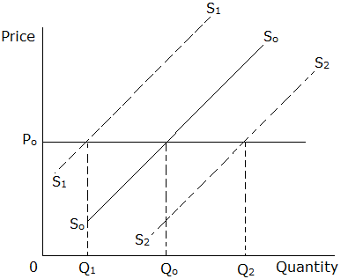

From the diagram above, SoSo is the original supply curve.

S1S1shows a shift of the supply curve inwards from SoSo representing a decrease in supply

S2S2shows a shift of the supply curve outwards from SoSo representing an increase in supply.

**FACTORS THAT CAUSE A CHANGE IN SUPPLY OF A COMMODITY**

1. Change in the cost of production.
2. Change in the number of firms in the industry.
3. Change in the level of demand for the commodity/ market size.
4. Change in the level of technology used in the production of the commodity.
5. Change in the objective of the firm.
6. Change in the gestation period of the commodity
7. Change in the level of supply of factor inputs/ availability of factors of production.
8. Change in the price of a jointly supplied commodity.
9. Change in the price of a competitively supplied product.
10. Change in the political climate in the area.
11. Change in natural factors/ climatic conditions.
12. Change in the level of development of infrastructures.
13. Change in the degree of freedom of entry of firms into the industry.
14. Change in government policy of taxation and subsidization.
15. Change in working conditions.
16. Expectation of future price changes.

**INCREASE IN SUPPLY**

This is an economic situation where more units of a commodity are supplied at a constant price due to other factors affecting supply of that particular commodity becoming (more) favourable.

Illustration

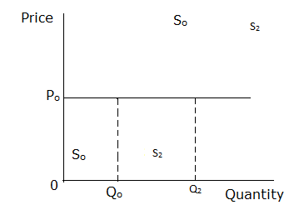

**CAUSES OF AN INCREASE IN SUPPLY**

1. Decrease in the cost of production.
2. Increase in the number of firms in the industry.
3. Increase in the level of demand for the commodity/ market size.
4. Improvement in technology used in the production of the commodity/ shift from inferior/ poor/ labour intensive technology to capital intensive/ superior technology.
5. Change in the objective of the firm from profit maximization to sales maximization
6. Reduction in the gestation period of the commodity
7. Increase in the level of supply of factor inputs/ availability of factors of production.
8. A fall in the price of a jointly supplied commodity.
9. Increase in the price of a competitively supplied product.
10. Political climate in the area becoming favourable
11. Natural factors/ climatic conditions becoming favourable
12. An improvement in infrastructures.
13. Increased freedom of entry of firms into the industry.
14. Government policy on production of a commodity becoming favourable.
15. Working conditions becoming favourable.
16. Expectation of future price fall

**DECREASE IN SUPPLY**

This is an economic situation where less units of a commodity are supplied at a constant price due to other factors affecting supply of that particular commodity becoming unfavourable.

Illustration

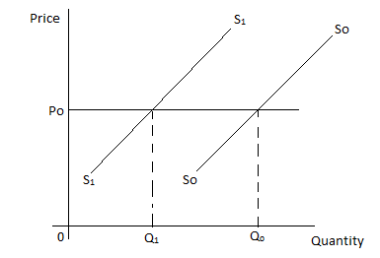

**ASSIGNMENT**

Account for a decrease in commodity supply in an economy (20 marks)

**CHANGE IN QUANITY SUPPLIED**

This is an economic situation where more or less units of a commodity are supplied due to changes in the price of the commodity keeping other factors determining supply constant.

it is illustrated by movement along the supply curve either upward due to price increase or downward due to price fall.

Illustration

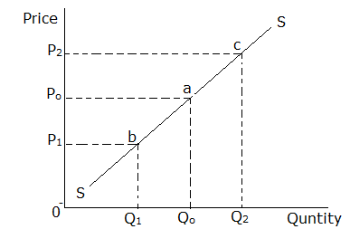

A fall in the price from OPo to OP1leads to a decrease in the quantity supplied from OQo to OQ1as illustrated by the movement along the supply curve from point a to b and this is known as a contraction in supply.

A rise in the price from OPo to OP2leads to an increase in quantity supplied from OQo to OQ2as illustrated by the movement along the supply curve from point a to c and this is known as an expansion in supply.

**INCREASE IN QUANTITY SUPPLIED**

This is an economic situation where more units of a commodity are supplied due to an increase in its price when other factors that affect supply of that particular commodity have not changed.

Illustration

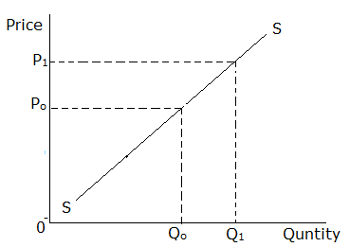

**DECREASE IN QUANTITY SUPPLIED**

This is an economic situation where less units of a commodity are supplied due to a decrease in its price when other factors that affect supply of that particular commodity have not changed.

Illustration

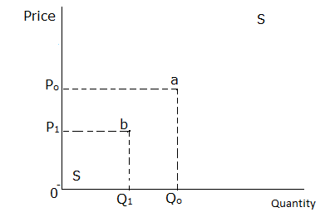

**RELATIONSHIP BETWEEEN DEMAND AND SUPPLY**

Demand and supply also looked at separately in the previous chapters do not operate in isolation. Forces of demand and supply are constantly operating in every market and in so doing affecting the level of prices. As forces of demand and supply operate, there comes a price at which the quantity that is demanded is equal to the quantity that is supplied. This gives rise to the **equilibrium concept**

The term equilibrium here is used to imply a state of balance where what is put on the market by the sellers is all bought off by the buyers without creating any shortages or surpluses.

**ILLUSTRATION OF THE EQUILIBRIUM CONCEPT**

**(THE MARKET EQUILIBRIUM)**

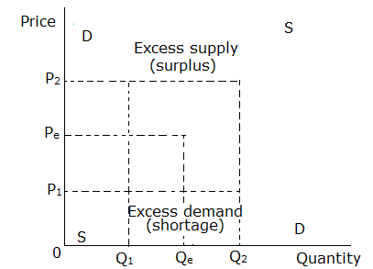

Where E = equilibrium point

Pe = Equilibrium price

Qe = Equilibrium quantity

An increase in price to OP2 leads to a fall in quantity demanded to OQ1 and an increase in Quantity supplied to OQ2. This creates a surplus of Q1Q2 on the market. As a result, producers are forced to reduce the price to OPe so as to dispose of the surplus.

A fall in price to OP1 leads to an increase in quantity demanded to OQ2 and a fall in quantity supplied to OQ1. This creates a shortage of Q1Q2 on the market. As a result, buyers are forced to offer a higher price of OPe so as to encourage producers to supply more and remove the shortage.

In case such a situation happens in the market, then OPe would be referred to as the **normal price.**

**NOTE**

1. Stable equilibrium is a situation whereby divergence from the equilibrium point can be restored through the interaction of market forces of demand and supply.
2. Unstable equilibrium is a situation whereby divergence form the equilibrium point can never be restored through the interaction of market forces of demand and supply.

**THE CONCEPT OF ELASTICITY**

Elasticity refers to the degree of responsiveness of the dependent variable to a change in the independent variable.

The dependent variable may be quantity demanded or quantity supplied while the independent variables are the factors which influence the above dependent variables.

Elasticity is broadly categorized into two;

1. Elasticity of demand
2. Elasticity of supply.

**ELASTICITY OF DEMAND**

This is the measure of the degree of responsiveness of quantity demanded of a commodity to changes in the factors that influence demand.

There are as many types of elasticity of demand as the determinants of demand.

However, we shall look at only the three most important ones i.e.

1. Price elasticity of demand (P.E.D)
2. Income elasticity of demand (Y.E.D)
3. Cross elasticity of demand (C.E.D)

**PRICE ELASTICITY OF DEMAND**

This is the measure of the degree of responsiveness of quantity demanded of a commodity to changes in its price.

**TYPES OF PRICE ELASTICITY OF DEMAND**

Price elasticity of demand ranges from zero to infinity (0 ≤ P.E.D ≤ ∞)

1. **Perfectly inelastic demand (P.E.D = 0)**

This is where a change in price does not affect the quantity demanded of the commodity. It is common with necessities. The demand curve is vertical.

Illustration

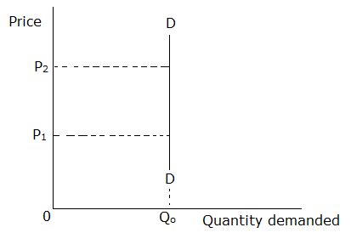

1. **Inelastic demand (Low price elasticity of demand) (0 < P.E.D < 1)**

This is where a big change in price results into a small change in quantity demanded. The slope of the demand curve is very steep.

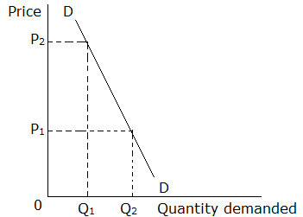

1. **Unit/ unitary elasticity of demand (P.E.D = 1)**

This is where a change in price results into an equal change in quantity demanded. The percentage change in price is equal to the percentage change in quantity demanded. It is illustrated by a rectangular hyperbola.

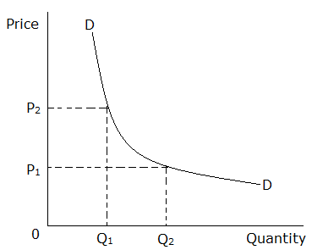

1. **Elastic demand(High elasticity of demand) (1 < P.E.D < ∞)**

This is where a small change in price results into a big change in quantity demanded. The demand curve is gently sloped.

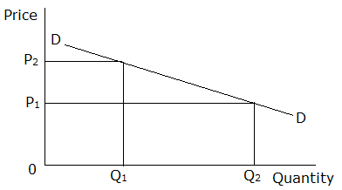

1. **Perfectly elastic demand(P.E.D = ∞)**

This is where different quantities of a commodity are demanded at a constant price. This means that the commodity has got perfect substitutes and therefore a seller cannot increase the price. The demand curve is horizontal.

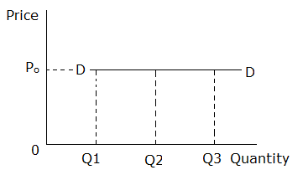

**METHODS OF MEASURING PRICE ELASTICITY OF DEMAND**

There are three methods of measuring price elasticity of demand. They are;

1. The percentage method
2. The point method
3. The arc method (Midpoint method)

**THE PERCENTAGE METHOD**

Price elasticity of demand can also be defined as the percentage (proportionate) change in the quantity demanded of a commodity due to a percentage (proportionate) change in the price of the commodity.

We use the formula;

$$Price elasticity of demand=(-)\frac{Percentage change in quantity demanded}{Percentage change in price}$$

**NB**

Due to the inverse relationship between price and quantity demanded, all calculations for price elasticity of demand for normal goods yield negative results. As a rule, we multiply the formula with a negative to make the price elasticity of demand a positive number so as to have a correct interpretation of the responsiveness.

Please note that this rule should only be applied for price elasticity of demand.

Worked examples

1. If the price of oil increases by 10% over a period of several years and the quantity demanded falls by 5%, what is the long run elasticity of demand for oil?
2. The price of a given commodity decreased from Shs 10,000 to Shs 9000 and as a result, quantity demanded increased by 25%. Calculate the elasticity of demand and interpret your answer.
3. Given that the price of the commodity decreased from Shs 500 to Shs 400 and as a result, the quantity demanded increased from 10kg to 20kg. Calculate the elasticity of demand and interpret your your answer.

Trial question

1. A change in price of a commodity from15/= to 5/= led to an increase in quantity demanded from 2kgs to 5kgs. Calculate the price elasticity of demand and interpret your answer.
2. Assuming that the price of the commodity rises from Shs 1500 to Shs 2000 per kg and as a result the quantity demanded falls from 20kg to 15kg. Calculate the elasticity of demand and interpret your answer.

**FACTORS THAT PRICE ELASTICITY OF DEMAND**

1. **Availability of substitutes/ degree of substitutability of the commodity.**

Demand for a commodity that has close substitutes is price elastic because consumers have alternatives to choose from depending on which one is cheaper. However, demand for a commodity that has no close substitutes is price inelastic because consumers have no alternative goods to turn to or from in case of a change in price.

1. **Availability of complements.**

Demand for a commodity which is a strong complement to what consumers have is price inelastic because consumers continue to buy despite price changes so as to derive satisfaction from the commodity it complements. However, demand for a commodity which is not a strong complement to what consumers have is price elastic because the consumers have a choice whether to buy or not in case of price changes.

1. **Proportion of the consumer’s income spent on the commodity.**

Demand for a commodity which takes a very small proportion of the consumers’ income is price inelastic since people do not feel the impact of the price changes so much. However, demand for a commodity which takes a big percentage of the consumers’ income is price elastic because consumers are sensitive to price changes and a rise in price would prompt them to cut or abandon consumption while a fall in price encourages higher consumption levels.

1. **Level of consumer’s income.**

Demand for a commodity is price inelastic among high income earners because they have the ability to continue consuming around the same quantities despite the rise in prices and a fall in prices may not excite them into consuming higher quantities. However, demand is price elastic among low income earners because they are very sensitive to price changes and they considerably vary the quantities they buy when prices change because to them, every shilling means a lot and must therefore be put to the best use.

1. **Degree of necessity of the commodity.**

Demand for a necessity like food is price inelastic because consumers cannot easily do without it and hence even if the price rises, consumers find themselves continuing to buy relatively the same quantities. However, demand for a luxury is price elastic because people can easily do without it if the price rises or reduce the amount consumed.

1. **Level of addiction in the use of the commodity.**

Demand for an addictive commodity like cigarette is price inelastic because such a commodity forms a habit in the consumer and he buys almost the same units regardless of the changes in price. However, demand for a non – addictive commodity is price elastic because the consumer easily reduces the amount demanded when prices increase.

1. **Level of durability of the commodity/ level of perishability of the commodity/ nature of the commodity i.e. perishable or durable commodity.**

Demand for a durable good like a television set is price inelastic because people do not have to purchase it frequently implying that a fall in price of such a good does not necessarily call for more of it to be bought by those who have it. On the other hand, demand for a perishable good is price elastic because the frequency of purchasing is high making consumers sensitive to price changes hence buying more when the price falls and less when the price increases.

1. **Number of uses of the commodity.**

Demand for a good that has several uses like electricity is price elastic because an increase in the price of the commodity makes consumers to use less of it for only vital purposes and a fall in the price makes consumers to increase its demand for even unimportant purposes. On other hand, demand for a good having a single use is price inelastic because a change in price affects demand for the commodity only in that use.

1. **Time period of consumption i.e. short run or long run.**

In the short run, the demand for a commodity tends to be price inelastic because it is difficult for consumers to find substitutes while in the long run, the demand for the commodity is price elastic because consumers are able to learn the market conditions and look for substitutes.

1. **Possibility of deferring consumption of the commodity.**

The demand for a commodity whose use can be postponed to a future date is price elastic because an increase in price makes consumers to abandon the purchase of the commodity until the price reduces. On the other hand the demand for a commodity whose use cannot be postponed is price inelastic because an increase in price has little effect on quantity demanded.

1. **Speculation about price changes**

When the consumers expect the price of the commodity to fall in future, the current demand tends to be price elastic because consumers easily reduce the amount demanded when the price slightly increases with hope of buying in the future at lower prices. On the other hand if consumers expect a future price increase, the current demand for the commodity tends to be price inelastic because consumers continue buying even if prices are rising due to fear of purchasing at very high prices in the future.

1. **Level of advertisement.**

Demand for a highly advertised good is price inelastic because the persuasive adverts convince the buyers to continue buying the commodity regardless of the changes in price. However, demand for a less advertised commodity is price elastic because of the limited awareness of the public about the commodity.

1. **Degree/ extent of convenience in acquiring/ accessing the commodity.**

Demand for a commodity that is conveniently accessible is price inelastic because consumers find no need to look for substitutes in case of price increment while demand for a commodity that is difficult to access is price elastic because an increase in price forces consumers to look for substitutes.

**CAUSES OF PRICE INELASTIC DEMAND**

1. The commodity not being substitutable/ the commodity having no substitutes.
2. The commodity being a complement
3. Proportion of the consumer’s income spent on the commodity being high
4. The commodity being a necessity
5. The consumer’s income being high
6. The commodity being habit forming/ addictive
7. The commodity being durable
8. The commodity having one or few uses
9. Short run situation
10. The consumption of a commodity not being deferrable.
11. Consumers speculating a future price increase
12. The commodity being highly advertised.
13. The commodity being conveniently accessible.

**ASSIGNMENT**

Explain the causes of high price elasticity of demand in your country.

**USES OF PRICE ELASTICITY OF DEMAND IN AN ECONOMY**

The concept of price elasticity of demand is of great importance to producers and government when making decisions especially those that may affect price.

1. **Producer (PPPAW)**
2. **Used in price determination.**

Price elasticity of demand helps the producer to fix prices for the commodity so as to maximize revenue. For commodities with elastic demand, the producer profits more by charging a low price and for commodities with inelastic demand, the producer profits more by charging a high price.

**NOTES**

In case the price elasticity of demand for a commodity is unitary, the producer does not need to change his prices.

1. **Used in price discrimination**

For price discrimination to succeed there should be geographical separation of the market into submarkets and the price elasticity of demand for the commodity should be different in different submarkets. The seller charges a high price in the submarket with inelastic demand and a low price in the submarket with elastic demand.

1. **Used to determine prices of joint products**

The concept of price elasticity of demand is of much use in the pricing of joint products like wool and mutton, wheat and straw, cotton and cotton seed, meat and hides, etc. In such cases, separate costs of production of each commodity are not known and therefore the price of each is fixed on the basis of its elasticity of demand. That is why products like wool, wheat, meat and cotton having an inelastic demand are priced very highly as compared to their byproducts mutton, straw, hides and cotton seeds with an elastic demand.

1. **Used to determine the intensity of advertisement.**

The concept of price elasticity of demand provides a guideline to a producer about the amount of money to spend on advertisement. For commodities with elastic demand, the producer needs to spend large sums of money on advertisement in order to increase the sales since increasing prices reduces the revenue. On the other hand, little or no advertisement is required for commodities with inelastic demand since the producer can increase revenue by raising prices.

1. **Used to determine the wage rate.**

The concept of price elasticity of demand is important in the determination of wages of a particular type of labour. Labour producing a commodity with inelastic demand is paid a high wage because the producer can recover the cost of labour by increasing the price of the commodity. However labour producing a commodity with elastic demand is a paid a low wage because passing on the cost to consumers in form of increased prices reduces demand significantly hence causing a fall in revenue.

1. **Government**
2. **Used to determine goods to be provided as public utilities.**

Government’s decision to declare certain industries as public utilities depends on elasticity of demand for their products. The state usually takes over production of products whose demand is inelastic and are essential to the public. This is because if production of such products is left in the hands of private individuals, they tend to overcharge the consumers because their main goal of production is profit maximisation.

1. **Used to determine the incidence of a tax.**

When government imposes an indirect tax, it is either paid by the producer or the consumer or a combination of the two depending on the price elasticity of demand. For inelastic demand, the consumer pays more tax than the producer. For elastic demand, the producer pays more tax than the consumer. For unitary elasticity of demand, the tax is shared equally between the producer and the consumer. The producer pays the tax alone if demand is perfectly elastic and the consumer pays the tax alone if the demand is perfectly inelastic.

1. **Used to determine the tax rate.**

Government imposes indirect taxes so as to raise revenue. Government raises more revenue by taxing highly commodities with inelastic demand because such commodities are demanded irrespective of the price changes. However, low taxes are imposed on commodities with elastic demand to avoid causing a drastic fall in their demand and the tax revenue received from them.

1. **Used while granting protection.**

Usually, a subsidy or protection is given to only those industries whose products have elastic demand. This is because they are unable to face foreign competition unless their prices are reduced through a subsidy or by imposing heavy duties on imported goods so as to increase their prices hence making them unaffordable to the consumers.

1. **It is a basis for the devaluation policy.**

The main objective of devaluation is to improve the country’s balance of payments position. Devaluation makes imports expensive thereby reducing their importation and exports cheaper thereby encouraging and increasing their volume. The policy can only be successful if the price elasticity of demand for both imports and exports is elastic.

1. **Consumers.**
2. **Helps a consumer to plan for his/her expenditure.**

Consumers plan to spend more on commodities whose demand is price inelastic and less on commodities whose demand is price elastic.

**ELASTICITY AND INCIDENCE OF A TAX**

Incidence of a tax refers to the final resting place of a tax and it falls on either the producer or the consumer or a combination of the two depending on the price elasticity of demand.

**Case 1: Taxation and perfectly inelastic demand**

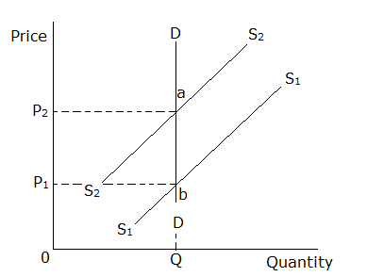

ab = total tax paid by the consumer.

When demand is perfectly inelastic, the total tax is paid by the consumer.

**Case 2: Taxation and perfectly elastic demand.**

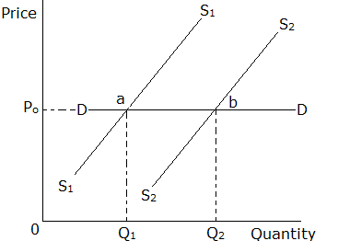

ab = total tax paid by the producer.

When demand is perfectly elastic, the total tax is paid by the producer.

**Case 3: Taxation and inelastic demand**

When demand is inelastic, the consumer pays more tax than the producer as illustrated below.

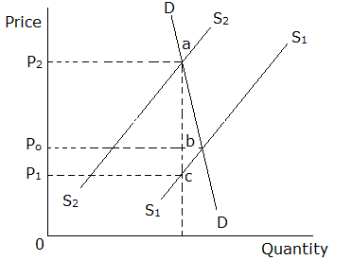

abc = total tax

ab = tax paid by the consumer

bc = tax paid by the producer

**Case 4: Taxation and elastic demand**

When demand is elastic, the producer pays more tax than the consumer.

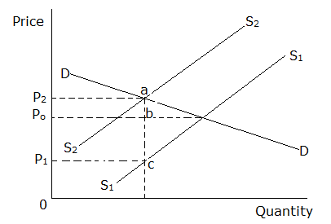

abc = total tax.

ab = tax paid by the consumer

bc = tax paid by the producer

**Case 5: Taxation and unitary demand**

When demand is unitary, the tax is shared equally between the consumer and the producer.

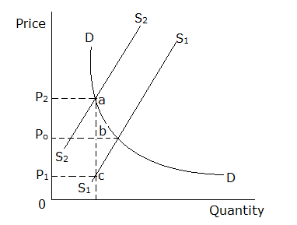

abc = total tax

ab = tax paid by the consumer

bc = tax paid by the producer

**INCOME ELASTICITY OF DEMAND**

This is the measure of the degree of responsiveness of quantity demanded of a commodity to a change in consumer’s income.

**OR**

It is the percentage change in the quantity demanded of a commodity due to a percentage change in the consumer’s income.

Income elasticity of demand = Percentage change in quantity demanded

Percentage change in price

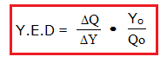

Where ∆Q = change in quantity demanded

∆Y = change in consumer’s income

Qo= original quantity demanded

Yo= original income.

**INTERPRETATION OF INCOME ELASTICITY OF DEMAND**

If Y.E.D is positive, the commodity is a normal good.

If Y.E.D is negative, the commodity is an inferior good.

If Y.E.D is zero, the commodity is a necessity.

Worked examples

1. Use the table below to answer the questions that follow;

|  |  |  |
| --- | --- | --- |
| Period | Income | Quantity |
| 2007 | 150,000 | 50 |
| 2008 | 200,000 | 80 |

1. Calculate the income elasticity of demand.
2. State the type of the commodity in question.

Solution

1. Given that;

Yo = 150,000

Y1 = 200,000

Qo = 50

Q1 = 80

1. The commodity is a normal good.
2. Use the table below to answer the questions that follow.

|  |  |  |
| --- | --- | --- |
| Period | Income | Quantity |
| 2007 | 150,000 | 50 |
| 2008 | 200,000 | 50 |

1. Calculate the income elasticity of demand.
2. State the type of the commodity in question.

Solution

1. Given that;

Yo = 150,000

Y1 = 200,000

Qo = 50

Q1 = 50

1. The commodity is a necessity.

.

Trial questions

1. Given that an individual’s income increased from shs 50,000 to shs 80,000 per month and this led to an increase in the demand for the commodity by 10%. Calculate the income elasticity of demand and comment on the type of the good.
2. Study the table below showing income and quantity demanded of commodity X and answer the questions that follow.

|  |  |
| --- | --- |
| Income (Ug. Shs) | Quantity demanded of X (kg) |
| 10,000 | 50 |
| 30,000 | 20 |

1. Calculate the income elasticity of demand for commodity X.
2. What type of commodity is X? Give a reason for your answer.

**IMPORTANCE OF INCOME ELASTICITY OF DEMAND**

1. A consumer is able to tell or predict the amount of a commodity which would be bought depending on the on the nature of the commodity. If it is an inferior good, less of it will be demanded following an increase in the consumers’ income. If it is a normal good, more of it will be demanded as ones income increases and if it is a necessity, quantity demanded remains constant irrespective of changes in the consumer’s income.
2. It helps in determining the type of a commodity i.e. inferior, necessity or normal good.
3. Helps the government in distribution of social utilities.
4. It helps importers in determining what to import.
5. Helps the government in policy making for example taxation.
6. Helps a seller / producer to predict future demand as income changes.

**CROSS ELASTICITY OF DEMAND**

This is the measure of the degree of responsiveness of quantity demanded of one commodity (X) due to a change in the price of another commodity (Y).

**OR**

This is the percentage (proportionate) change in quantity demanded of one commodity due a percentage change in the price of another/ related commodity.

Cross elasticity of demand = Proportionate change in quantity demanded of commodity X

Proportionate change in the price of commodity Y

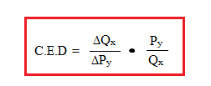

Where ∆Qx= change in quantity demanded of commodity X

∆Py= change in the price of commodity Y

Py= original price of commodity Y

Qx= original quantity of commodity X

**INTERPRETATION OF CROSS ELASTICITY OF DEMAND**

Here we give the relationship between the two commodities.

If C.E.D is positive, the two commodities are substitutes.

If C.E.D is negative, the two commodities are complements.

If C.E.D is zero, the two commodities are unrelated/ there is no relationship between the two commodities.

Worked example

Given that the price of commodity X increased from Shs 50,000 to Shs 80,000 and this led to increase in quantity demanded for commodity Y by 10%. Calculate the cross elasticity of demand for the two commodities and state the relationship between them.

Solution

Given that;

Po = shs 5,000/=

P1 = shs 80,000/=

Quantity demanded for commodity Y changed by 10%

$$C.E.D=\frac{\%age ∆ in qnty demanded for commodity Y}{\%age ∆ in the price of commodity X }$$

$$\%age ∆ in price of commodity X=\frac{P_{1}-P_{O}}{P_{O}}×100$$

$$=\frac{80,000-50,000}{50,000}×100$$

$$=\frac{30,000}{50,000}×100$$

$$=60\%$$

$$C.E.D=\frac{10\%}{60\%}=\frac{1}{6}=0.167$$

X and Y are substitutes.

Trial questions

1. Given that an increase in the price of commodity X form Shs 1500 to Shs 1800 resulted into a change in quantity demanded for commodity Y from 600 units to 570 units;
2. Calculate the cross elasticity of demand
3. State the relationship between commodities X and Y.
4. If the price of commodity X falls from Ug. Shs 2,000,000 to Ug. Shs 1,600,000 per unit and the quantity demanded of commodity Y increases from 40,000 to 60,000 units,
5. Calculate the cross elasticity of demand.
6. State the relationship between commodities X and Y.

**ELASTICITY OF SUPPLY**

This is the measure of the degree of responsiveness of quantity supplied of a commodity to changes in factors which influence supply.

Under elasticity of supply, we shall only look at price elasticity of supply and cross elasticity of supply.

**PRICE ELASTICITY OF SUPPLY**

This is the measure of the degree of responsiveness of quantity supplied of a commodity to a change in its price.

**OR**

This is the percentage change in the quantity supplied of a commodity due to a percentage change in the price of the commodity.

$$Price elastcity of supply=\frac{ Percentage change in quantity supplied}{ Percentage change in the price of the commodity}$$

**INTERPRETATION OF PRICE ELASTICITY OF SUPPLY**

1. **Perfectly inelastic supply (P.E.S = 0)**

This is where price changes do not affect the quantity supplied i.e. quantity supplied remains constant at different price levels.

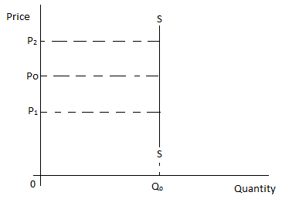

1. **Inelastic supply (0<P.E.S<1)**

This is where a big change in price results in into a small change in the quantity supplied. This is common with agricultural products that take long to be produced.

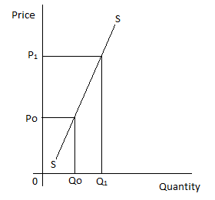

1. **Unitary supply (P.E.S = 1)**

This is where a change in price results into an equal change in the quantity supplied.

This is an ideal situation which does not occur in reality.

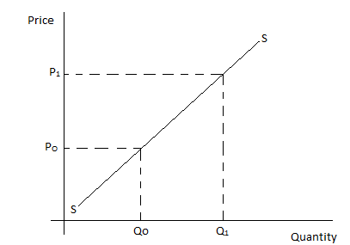

1. **Elastic supply (0<P.E.S< $∞$)**

This is where a small change in price results into a big change in quantity supplied.

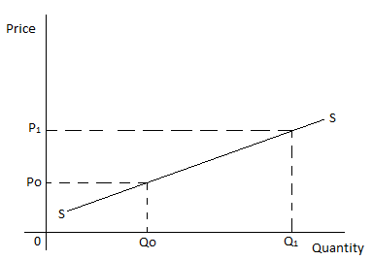

1. **Perfectly elastic supply**

In this case, price of a commodity is constant at all levels of the quantity supplied. This situation does not exist in the real world.

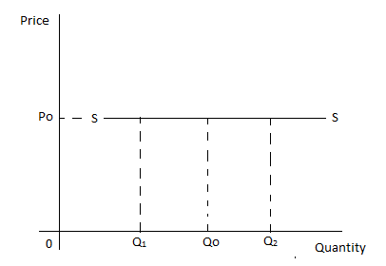

Worked examples

1. The price of a commodity increased from shs 800 to shs 1200 per kg and the quantity supplied in the market increased from 2000kgs to 5000kgs. Calculate the price elasticity of supply.

Exercise

1. An increase in price from 60,000 to 90,000 led to an increase in quantity supplied of commodity by 50%. Calculate the price elasticity of supply.
2. An increase in price from shs 40/= to 400/= led to an increase in the quantity supplied of a commodity from 30kgs to Xkgs. If the price elasticity of supply is 2, find the value of X.

**FACTORS THAT INFLUENCE PRICE ELASTICITY OF SUPPLY**

1. **Existence of stocks.**

Availability of stocks held by producers and distributors makes supply elastic since as prices rise supply can be increased by drawing from the existing stocks. On the hand, absence of stocks makes supply inelastic because it is not possible to increase supply by drawing from the available stocks.

1. **Nature of the commodity i.e. durable or perishable.**

Durable commodities have elastic supply because they can be stored and as prices rise, supply can be increased by drawing from the existing stocks and a fall in price makes producers to store much of their products. However, perishable commodities have inelastic supply because as prices rise, quantity supplied cannot easily be increased since nothing was stored in periods of peak production and a fall in price does not reduce quantity supplied significantly since the goods cannot be stored for long.

1. **Gestation period/ Length of the production process.**

Goods that have a short gestation period have elastic supply because it is possible to adjust production in a short time while goods that have a long gestation period have inelastic supply because producers are unable to raise or reduce their output easily when prices rise or fall respectively.

1. **Time period in production.**

In the short run, supply is inelastic because some factors of production are fixed and output levels can be changed by only changing the variable factors of production like labour. However in the long run, supply is elastic because all factors of production are variable and hence firms are in position to either expand their production capacities or contract them to respond to price changes by varying the amount of each factor of production employed.

1. **Degree of freedom of entry of new firms in the industry.**

Free entry of new firms in the industry makes supply to be price elastic because an increase in price attracts other firms to join and increase production of the commodity and when prices and profits fall, they exit. However, restricted or blocked entry of new firms in the industry makes supply to be inelastic because when price increases, other firms cannot join the industry to increase output levels.

1. **Objective of the firm.**

Supply is inelastic for goods whose producers’ main objective is profit maximisation since they limit production and supply to force the prices upwards. However supply is elastic for goods whose producers’ aim at sales maximisation since more output is put on the market whenever prices increase so as to maximize sales.

1. **The level of technology used in production.**

High level of technology makes it possible to easily adjust output levels to match price changes and hence supply is elastic. However backward technology limits output levels thereby making supply to be inelastic since even if prices rise, output is not likely to follow suit.

1. **Complexity of the production process**

The more complex the production of a good, the more inelastic supply becomes due to the fact that a complex production process limits the ability of producers to especially increase output levels. Therefore for goods that are produced through a complex process like automobiles, supply is inelastic while for those which have a simple production process like textiles, supply is elastic.

1. **Availability of factors of production/ level of supply of factor inputs.**

High supply of factor inputs makes supply to be price elastic because it is easy to adjust factor combinations to alter quantity supplied in the market. However scarcity of factor inputs makes supply to be price inelastic because it is hard to adjust the factor combinations to respond to price changes.

1. **Production capacity of the firms.**

Operation of firms at excess capacity makes supply to be price elastic because it is possible for such firms to employ the redundant resources to increase output when prices rise. However operation of firms at full capacity makes supply to be price inelastic because there are no redundant resources that firms can exploit to increase output levels in response to a rise in price.

1. **The cost of production.**

High production costs make supply to be price inelastic because they act as barriers to expand output levels and despite higher prices in the market, firms find it hard to increase supply since it would require considerably higher amount of money. However low production costs make supply to be price elastic because firms can easily adjust their output levels as prices change in the market

1. **Government policy of taxation and subsidisation.**

Favourable government policy in form low taxes, high subsidies and other incentives makes supply price elastic because of the reduction in the average costs of production that enables the producers to increase output in response to a price increase. However, unfavourable government policy in form of high taxation and limited subsidies makes supply price inelastic because of the increase in the costs of production that makes it difficult for producers to increase output even if there is a rise in price.

1. **Natural factors.**

Favourable climatic conditions like reliable rainfall make supply of agricultural products to be elastic because more output can be put on the market in response to a rise in price. However unfavourable climatic conditions like prolonged droughts make supply of agricultural products to be inelastic because output levels cannot be increased even if there is a price increase.

1. **Political climate.**

Favourable political climate in an economy makes supply price elastic because production of a commodity is encouraged due to the confidence among producers in regard to national security. However, unfavourable political climate in an economy makes supply price inelastic since production is discouraged as the producers have fear for loss of their life and property.

1. **Level of development of infrastructure.**

Well developed infrastructure like good roads make supply to be price elastic because producers can easily increase supply in response to a price increase due to increased access to the market. However, poor infrastructure like bad roads make supply price inelastic because products are not available on time in response to price increments due to limited access to the market.

1. **Degree of factor mobility**

Mobility of factors of production makes supply price elastic because producers can easily switch resources to production of the commodity whose price has increased. However, immobility of factors of production makes supply price inelastic because producers cannot easily switch resources to production of the commodity whose price has increased.

1. **Future price expectations.**

Expectation of a future price fall relative to the current prices makes current supply of the commodity to be price elastic because producers sell more now to avoid making losses in the future when the prices have fallen. However, Expectation of a future price increase relative to the current prices makes current supply to be inelastic because producers supply less even if prices increase because they are waiting to sell at high prices in the future and make a lot of profits.

1. **Price of a jointly supplied product.**

A low price of a jointly supplied product makes supply of the commodity in question to be price inelastic because it discourages production of the commodity in question even if the price is increasing. For example a low price of maize flour makes supply of maize bran to be inelastic. However a high price of a jointly supplied product makes supply of the commodity in question to be price elastic because it encourages production of the commodity in question.

1. **Price of a competitively supplied product.**

A high price of a competitively supplied product makes the supply of the product in question to be price inelastic because it makes production of the commodity in question unprofitable. However, a low price of a competitively supplied product makes supply of the commodity in question to be price elastic because it makes it makes production of the commodity in question profitable.

**Factors that lead to high price elasticity of supply in an economy**

* Availability of stocks
* Durability of a commodity/ commodity being durable.
* Short gestation period/ commodity having a short gestation period
* Long run period in production.
* Freedom of entry of new firms into the industry.
* Objective of the firm being sales maximisation.
* Use of advanced/ efficient technology/ high level of technology
* Production process being simple
* High supply of factors of production/ factor inputs.
* A firm operating at excess capacity
* Low costs of production
* Government policy on production/ supply being favourable/ favourable government policy on investment/ provision of government incentives/ low taxation levels.
* Presence of favourable natural factors
* Political stability/ favourable political climate/atmosphere/ political climate in a country being favourable.
* Well developed infrastructure/ high level of infrastructural development.
* Expectation of future decrease in price of the commodity.
* High price of jointly supplied product in relation to the commodity in question.
* Low price of competitively supplied commodity in relation to the commodity in question.

**Causes of price inelastic supply of agricultural products in Uganda**

* Long gestation period of agricultural products.
* Bulkiness of agricultural products.
* Perishability of agricultural products.
* Unfavourable natural factors.
* High costs of production
* Poor surplus disposal system/ machinery.

**Assignment**

When may price elasticity of supply for a commodity be low in an economy?

**CROSS ELASTICITY OF SUPPLY**

This is the measure of the degree of responsiveness of quantity supplied of one commodity (X) to a change in the price of a related commodity (Y)

$$Cross elasticity of supply=\frac{Percentage change in quantity supplied of X }{Percentage change in price of commodity Y}$$

**Example**

Given that the supply of a commodity **P** has increased from 400 units to 600 units per week due to a decrease in price for commodity **Z** from Shs 100 to Shs 80 per unit.

1. Calculate the elasticity of supply of commodity **P**.
2. Give two possible examples of **P** and **Z**.

**PRICE MECHANISM (PROFIT – PRICE MECHANISM/ THE INVISIBLE HAND) AND RESOURCE ALLOCATION**

Price mechanism is a system in free enterprise economy where prices in the market are determined by market forces of demand and supply with limited or no government intervention.

Price mechanism is a system where prices act as **automatic signals** in the allocation of resources.

To understand better the concept of price mechanism, we need to note the following.

1. Demand dictates what is to be supplied by the producers.
2. Consumers’ expenditure is equal to seller’ revenue. It means that one’s expenditure on a commodity is what a seller gets as his or her income.
3. Consumers are regarded as voters. It follows that whenever consumers buy a product, they are casting votes in favour of production and supply of the commodity.
4. Consumers take an upper hand in deciding what is to be producedi.e. there is consumer sovereignty where a consumer takes a leading role in determining allocation of resources.

**ASSUMPTIONS OF PRICE MECHANISM**

1. It assumes existence of a free enterprise economy where resource allocation is determined by the interaction of market forces of demand and supply.
2. There is no government intervention/ interference as far as pricing and output policies of the producers are concerned.
3. There are many buyers and sellers, hence no monopoly to influence market conditions.
4. Producers aim at profit maximization and they produce commodities whose price is high.
5. Consumers aim at utility maximization and thus they buy from the cheapest source.
6. There is free entry and exit in the market i.e. when super normal profits are earned, firms are free to join the industry and when profits are exhausted, inefficient (high cost) firms leave the industry.
7. There is consumer sovereignty in the market i.e. consumers have an upper hand in deciding what is to be produced by “casting votes” to commodities as they buy.
8. It assumes no wastage of resources because producers only supply what consumers want at a particular time.
9. There is perfect mobility of factors of production, so resources go where the price is high.
10. There is perfect knowledge about market conditions by both sellers and buyers for instance consumers know the price and qualities of the products on the market.

Price mechanism responds to the basic economic questions by providing appropriate answers to these questions. These questions are;

* What to produce?
* How to produce?
* When to produce?
* Where to produce?
* How much to produce?
* For whom to produce?

**THE ROLE OF PRICE MECHANISM IN THE ALLOCATION OF RESOURCES**

**NB**

We consider the **functional role** of price mechanism in the allocation of resources i.e. we focus on **what price mechanism does** in the process of allocating resources in an economy.

1. **It guides on what to produce.**

The producers are induced to produce and supply a commodity at a high price in order to make profits.

1. **It determines where to produce/ it determines the location of the production unit.**

Producers always locate their production units in areas where demand for the goods is high and consumers are ready to buy at a price that enables them to make a profit.

OR

Producers decide to locate their business firms in areas with the lowest costs of production. The aim is to maximise profits through minimising costs.

1. **It determines when to produce.**

Producers always produce more of a good at that time when demand for it is high so as to make profits.

1. **It determines how much to produce.**

Demand dictates the quantity of goods that producers supply on the market. This checks the danger of over production and wastage is avoided.

1. **It determines for whom to produce/ it determines the distribution of goods and services.**

Producers supply goods to those consumers who are able to buy at the prevailing market price.

OR

Producers supply goods to those consumers who have effective demand.

1. **It determines how to produce/ it determines the type of technology to be used in production.**

Producers employ cheap but efficient techniques of production. The aim is to maximise profits through minimising costs.

1. **It guides consumers when making choice of which goods to buy.**

Holding other factors constant, consumers buy more units of a commodity whose price is low and fewer units of a commodity whose price is high.

1. **It ensures efficient allocation of resources.**

Resources are allocated to producing those goods with the highest prices. Producers get the incentive to supply goods at high prices in order to get high profits.

1. **It determines income distribution.**

Income is distributed among producers depending on the price at which they supply and sell their goods. Therefore, producers who supply goods at high prices earn more incomes than those who supply goods at low prices.

1. **It provides an incentive for economic growth.**

This arises where high prices encourage high production of goods and services. As more goods and services are produced, economic growth is attained.

1. **It ensures production of better quality products because of competition among producers.**

Producers compete for the available market in order to supply their goods. Due to this competition, better quality goods have to be produced so that producers maintain and increase the level of demand for their goods.

**IMPLICATIONS OF PRICE MECHANISM**

**POSITIVE IMPLICATIONS (MERITS)**

**NB:**

Here we focus on the positive outcomes/ desirable outcomes (good things) which arise from price mechanism.

1. **It promotes consumer sovereignty.**

Individual households make their own decisions since the consumers influence what is to be produced. The goods and services which consumers demand for are the ones produced and supplied. The consumer becomes a **king** in influencing productive activities.

1. **It ensures efficiency of firms.**

Firms strive for efficient operations so as to survive competition and sell at high prices since high prices lead to high profits. This enables producers to expand their scale of production and become more efficient

1. **It encourages competition which leads to production of better quality goods and services.**

Consumers are more willing to pay a high price for high quality goods. Therefore producers strive to get the high prices by improving the quality of commodities.

1. **The profit motive encourages innovations and inventions (research).**

Due to the profit motive, producers develop new and better techniques of production. The improved methods of production result into increased output of better quality which is sold at high prices. This enables producers to get more profits.

1. **It avails a wide variety of goods and services to consumers.**

Price mechanism generates competition among producers. This gives rise to a greater variety of goods and services in an economy. Consumers are able to exercise choice and their standard of living is improved.

1. **It leads to efficient allocation and utilization of resources.**

Price mechanism enables producers to allocate the scarce resources in the production of those goods needed by the consumers. Producers allocate more resources to those goods whose demand is high and fewer resources are allocated to those goods whose demand is low.

1. **It leads to increased employment opportunities.**

As prices of goods rise (increase), producers supply more of those goods. Producers expand their scale of production and more people get employed in production units.

1. **It promotes incentive for hard work among producers leading to increased production.**High prices of goods motivate or encourage producers to work hard and supply more goods to consumers. This promotes economic growth in the country.
2. **It reduces the costs of administration due to limited or no government intervention.**

The forces of demand and supply guide the allocation of resources without government interference using price controls. The government does not incur costs of enforcing minimum and maximum prices.

1. **It helps to reward the various factors of production in the factor market.**

Factors which enable production of goods with high demand and prices are paid higher rewards. However, those factors whose output has low demand and low prices are paid low rewards.

1. **It encourages flexibility in production.**

Producer use the price and profit signals to change from less profitable to more profitable economic activities. For example a coffee farmer may change from the growing of coffee to the growing of vanilla should the price of vanilla become higher than that of coffee.

1. **It encourages arbitrage which benefits producers.**

Producers transfer goods from areas with low prices to sell them in areas with high prices. This benefits producers because they earn more revenue from sales and subsequently make higher profits.

**NB:**

Arbitrage is the practice of transferring goods from areas with low prices to areas with high prices in order to gain from the difference in prices. For example if a bag of in Jinja costs shs 120,000 and it costs shs 150,000 in Kampala, a trader may transfer bags of sugar from Jinja and sells them in Kampala so that he gains from that difference in price.

**NEGATIVE IMPLICATIONS / DEMERITS/ DEFECTS/ WEAKNESSES/ SHORTCOMINGS/ DISADVANTAGES OF PRICE MECHANISM**

**NB:**

Here we focus on those **undesirable outcomes or bad things** associated with price mechanism.

1. **It leads to consumer exploitation by producers due to ignorance or market imperfections.**

Price mechanism assumes that a consumer has perfect knowledge about the market conditions. However, many consumers are not aware of price changes and new goods on the market and thus they are exploited by profit – hungry producers.

1. **It leads to emergence of monopoly and its negative consequences.**

Price mechanism creates private monopoly because of excessive competition which forces inefficient firms out of production and efficient firms take over the market. The monopoly firms restrict output in order to charge high prices. They also supply low quality goods due to absence of competition in the market. This leads to exploitation of consumers.

1. **It promotes income inequality.**

Efficient producers whose goods are highly demanded receive higher incomes than the inefficient producers. Therefore the efficient producers get access to most of the resources in the economy. This creates income disparity with its associated disadvantages of exploitation of the poor by the rich.

1. **It encourages divergence between social costs and private benefits.**

Price mechanism does not consider the negative effects inflicted on the society as producers exploit the natural resources. Private investors benefit through profit maximization without taking into account social costs. For example when forest trees are cut down to get timber, there is a danger of deforestation and its negative impact on the environment, pollution created by private enterprises, over exploitation of resources. Unfortunately, these social costs are not considered under price mechanism.

1. **It leads to unemployment.**

This is due to automation (use of capital intensive techniques of production) and out competition of inefficient firms making people who were employed in those firms to lose jobs. The unemployed people experience low standards of living.

1. **It leads to economic instabilities like inflation, price fluctuations and balance of payments problems**.

This is due to absence of government intervention.

1. **It leads to underutilization of resources.**

Price mechanism creates excess capacity in certain cases. Producers abandon production of those goods which are not highly demanded. This leaves some resources to be idle or underutilized.

1. **It leads to wastage of resources due to wasteful competition.**

Price mechanism brings about stiff or cut-throat competition among private investors. Excessive competition among producers leads to resource wastage.

1. **It fails to allocate resources in priority sectors i.e. it does not provide public and merit goods/ it ignores socially profitable ventures.**

Price mechanism is not used to provide public goods such as public hospitals, roads and schools. The provision of such socially desirable goods is done by the government.

1. **It does not respond quickly or adjust quickly to structural changes in an economy.**

Price mechanism does not respond to circumstances requiring rapid structural changes such as privatization, modernization of agriculture, liberalization of trade, alleviating effects of natural disasters, etc. Such rapid structural changes call for government intervention.

1. **It leads to distortion of consumer choices through persuasive advertising.**

As private investors try to capture market for their goods, they undertake persuasive advertisements. As a result, many consumers end up buying goods which they would not have bought and thus their choices are distorted.

1. Foreign dominance of an economy is prominent most especially if the economy is open.
2. It leads to disappearance of cheap goods from the market because private individuals only venture in activities that enable them maximize profits.
3. It makes government planning difficult since it is associated with a number of uncertainties.

**METHODS/ WAYS OF INTERFERING WITH PRICE MECHANISM**

1. **Use of taxation policies.**

For instance adoption of Progressive taxation policy helps in redistributing income in an economy because the tax rate increases with increase in the tax payer’s income i.e. it takes a higher proportion of income of the rich than the poor hence narrowing the gap between the rich and the poor. Taxation can also be used to influence resource allocation whereby for sectors government wants to promote, no taxes are levied on their activities while for sectors and activities that government finds less desirable, high taxes are levied on them.

1. **Provision of public goods by the government.**

For example the provision of better transport network in form of roads helps in the movement of goods from areas where they are in plenty to those areas where goods are scarce. Hence shortages of goods created through the market forces of demand and supply are solved or checked.

1. **Encouragingthe setting up of consumer protection associations.**

These help in sensitizing the consumers about the ways in which they can be exploited by profit – hungry traders. The consumers are educated on how they can safeguard themselves against buying expired goods and adulterated goods as well as other forms of exploitation by traders.

1. **Anti-monopoly legislation**

Government enacts laws aimed at checking monopoly powers of private producers or investors. This is aimed at reducing consumer exploitation associated with monopoly firms.

1. **Setting up regulatory bodies to minimize social costs.**

Such bodies set laws which govern exploitation of resources, laws that protect wetlands, laws that enforce proper disposal of industrial wastes, etc. A case in Uganda is The National Environment and Management Authority (NEMA) that was set up to protect the environment.

1. **Setting up and strengthening bureau of standards.**

A bureau of standards is in charge of inspecting goods being produced to ensure that certain quality specifications are fulfilled before goods are put on the market. A certification mark is given for goods that fulfill the required quality standards and this protects the health of consumers.

1. **Licensing.**

The government puts certain restrictions on the licensing of traders such that licenses are given to only those traders or enterprises approved by the licensing department. This checks the carrying out of illegal or illicit trade.

1. **Planning for the economy.**

Economic development plans are drawn up by the government to guide the allocation of resources in both the private public sector. The aim is to avoid misallocation of resources associated with price mechanism.

1. **Subsidization of firms especially those providing essential and merit goods.**

The government offers subsidies to firms to produce essential goods and services so that the consumers are able to get such goods and services at lower prices.

1. **Adoption of price legislation policy/ control.**

Price controls are taken to even out fluctuations in prices. The government can either set a maximum price to protect consumers or a minimum price to protect producers depending on the economic situations at that time.

1. **Setting up government owned firms to compete with private monopolies.**

Government can set up non-profit making enterprises which are vital to the society. Such enterprises can compete with the private producers thus reducing on consumer exploitation.

1. **Carrying out nationalization of private enterprises.**

This is done to ensure that all essential goods and services are produced and supplied by nationalized enterprises at fair prices.

**NB:**

**Nationalization is…**

1. **Rationing of scarce commodities.**

It involves direct action by the government to distribute the scarce commodities to the public at fixed prices in limited quantities. This is done in periods when goods are scarce in order to reduce consumer exploitation by the traders. For example in 1986 – 1987, the government of Uganda used this policy by rationing the supply of essential goods like sugar, salt, soap to consumers through local councils.

1. **Controlling/ fighting inflation.**

The government through the central bank uses a restrictive monetary policy to reduce the amount of money in circulation. This reduces the purchasing power of households/ public. Consequently, aggregate demand falls and prices become stable.

1. **Use of buffer stocks.**

A buffer stock is a system or scheme which buys and stores stock in times of plenty and releases the stocks in times of scarcity. The buffer stock is managed by the government and it helps in stabilizing prices of goods on the market.

**REASONS FOR GOVERNMENT INTERFERENCE IN PRICE MECHANISM**

Due to the weaknesses or defects of price mechanism, government interferes in the allocation of resources through the forces of demand and supply for the reasons below;

1. **To reduce consumer exploitation by the profit – hungry business community.**

This arises due to consumer ignorance/ market imperfections. The profit – hungry traders exploit consumers through over charging, sale of fake products, product adulteration, sale of expired goods etc. Such trade malpractices call for government intervention through setting up and strengthening the bureau of standards.

1. **To control monopoly power in an economy where consumer preference is ignored.**

The government intervenes by imposing heavy taxes on the profits of monopolists. The aim is to fight the dangers associated with private monopolies such as overcharging of consumers and production of poor quality goods.

1. **To reduce income inequality.**

The government intervenes through progressive taxation so as to reallocate resources and attain equity in income distribution.

1. **To minimise social costs that arise as private investors pursue their private gains.**

Such costs include over exploitation of resources, pollution of the environment, deforestation among others. The government intervenes by setting up regulatory bodies that enact laws geared to protecting the environment by regulating the actions of firms during resource exploitation.

1. **To reduce unemployment which arises as inefficient firms are outcompeted.**

The government intervenes by subsidising the inefficient firms to enable them lower their production costs and survive the stiff competition. This guards against unemployment.

1. **To reduce economic instabilities like inflation i.e. to stabilize the economy.**

The government intervenes through price controls to ensure stability in prices of goods and incomes of producers.

1. **To cater for the provision of public goods.**

Goods such as public roads andnational security cannot be provided through the market forces of demand and supply hence a need for government interference.

1. **To encourage production and consumption of merit goods.**

These include education, medical care and safe water. A case in Uganda is the funding of the Universal Primary and Secondary Education by the government.

1. **In order to plan for rapid structural changes in the economy that cannot be handled by price mechanism.**

Structural changes such as rehabilitation of basic infrastructure after periods of war, privatization and modernization of agriculture call for government interference.

1. **For purposes of avoiding duplication of activities.**

The government intervenes by setting up one public enterprise to run an activity. This avoids wastage of resources.

1. **To control distortion of consumer choices.**The government intervenes by legislating prices of commodities so as to avoid consumer exploitation by the producers in form of persuasive advertising.
2. To encourage investment in areas that may appear risky.
3. **To provide goods needed by the poor.**

In some cases, government subsidises such goods so that they become affordable to the poor people in the economy. The aim is to improve the quality of life of the poor people.

**LIMITATIONS OF PRICE MECHANISM**

In this case, we focus on those factors that slow down or distort the effective allocation of resources through the price mechanism. A student needs to be well versed with the assumptions of price mechanism.

1. **Government intervention/ interference.**

In most economies, government interferes with the inter-play of market forces through price controls and taxation policies. This discourages some producers and they reduce the amount of goods supplied on the market. In this case, supply does not match with the consumers’ demand and price mechanism is distorted.

1. **Ignorance of the producers and consumers.**

Generally, producers and consumers do not have perfect knowledge of the market conditions. Some producers tend to supply goods without judging the condition in the market. Consumers too are not always aware of the availability of certain products and their prices. This creates slow response between demand and supply hence limiting price mechanism.

1. **Existence of monopolies**

There are many monopolies who tend to be price makers. They always restrict output in order to charge high prices and exploit consumers. They do not supply goods according to the demand by the consumers and this distorts the use of price mechanism in the allocation of resources.

1. **Limited entrepreneurial skills.**

Poor organization of factors of production and failure to take risks limits producers from responding to consumers demands. Producers fail to supply those goods needed by consumers and this slows down the operation of price mechanism.

1. **Under developed infrastructure.**

A poor road network limits the supply of goods to areas where they are needed. Consumers may desire to buy goods but are not accessible due to poor transport and distribution network.

1. **Inability to forecast future trends.**

Failure of producers to anticipate increased demand in future gives rise to low output and this leads to scarcity of goods. Alternatively, over production can occur where producers anticipate increased demand yet actual demand is low. This creates a gap between demand and supply hence price mechanism is distorted.

1. **Limited capital.**

Inadequate supply of real and money capital leads to low output. This makes producers to supply less than what is required by consumers. As a result, shortages of goods arise on the market hence limiting the operation of price mechanism.

1. **Limited skilled labour.**

The existence of few people with the necessary and relevant skills makes supply not to respond to the demand of consumers because of fewer volumes of goods being suppliedhence limiting the effective operation of price mechanism.

1. **Immobility of factors of production.**

Some factors of production do not move with ease from one place of work to another or from one geographical area to another. Therefore producers may fail to increase output hence supply does not respond to demand thus limiting the operation of price mechanism.

1. **Irrationality of producers and consumers.**

Price mechanism assumes that producers and consumers are rational which is not always true. Many producers and consumers are not guided by a calculating mind.

1. **Reliance on imported goods.**

This makes local consumers to have little influence on prices, quality, designs, etc of such imported goods.

1. **Band wagon effect.**

Many people consume certain commodities because they have seen others consuming them. Therefore price mechanism may not operate since such consumers are not rational.

**PRICE LEGISLATION/ PRICE CONTROL**

Price control is where the government fixes prices of commodities that is either maximum price to protect consumers or minimum price to protect producers.

**OR**

Price legislation is the deliberate government act of fixing price either above or below the equilibrium and it becomes illegal to sell below or above respectively.

Price control or legislation takes two major forms namely;

1. Maximum price legislation.
2. Minimum price legislation.

**MAXIMUM PRICE LEGISLATION**

This is the setting/ fixing of prices of commodities by the government below the equilibrium price above which it becomes illegal to sell or buy a commodity. It protects consumers.

The result of maximum price legislation is a maximum price/ price ceiling.

**Maximum price/ price ceiling**

Refers to the price set by the government below the equilibrium price above which it becomes illegal to sell or buy a commodity. It protects consumers.

Illustration

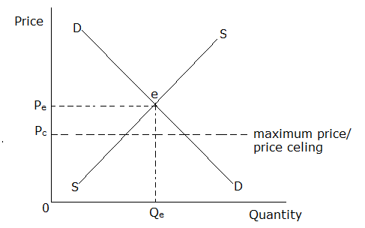

OPe = equilibrium price

OQe = equilibrium quantity demanded or supplied

OPc = maximum price/ price ceiling

It should be noted that no seller is allowed to sell above OPc which is the maximum price.

**MERITS OF MAXIMUM PRICE LEGISLATION**

1. Protects consumers from exploitation by producers through over charging.
2. Controls monopoly power since monopoly to a greater extent is a price maker.
3. Avails commodities to all groups of people in the economy. A maximum price makes the commodity affordable to all people and therefore more units are bought.
4. Reduces income inequality because it reduces the profits of producers and expenditures of consumers.
5. Controls inflation because the price is set below the equilibrium price and it is illegal to sell or buy above it.
6. Widens consumers’ choice thereby improving on peoples’ standards of living.
7. Helps to increase on aggregate demand thus stimulating investment and economic growth.
8. Discourages production of harmful products such as alcohol, cigarettes, marijuana, etc and this benefits the entire society.
9. Discourages importation of expensive commodities and encourages exports. This increases the foreign exchange earnings of the country.

**DEMERITS**

1. Discourages entrepreneurship development since it reduces the profit margins of producers.
2. Results into shortages of commodities since the legislated prices tend to be less attractive to producers.
3. Leads to trade malpractices such as black marketing, hoarding of commodities, smuggling hence reducing the supply of goods and services in the market.
4. Results into production at excess capacity as a number of resources are not put into use.
5. It leads to rationing. This is because it creates scarcity of goods and as a result, the government is forced to restrict the consumption of scarce commodities on the basis of first come first serve hence leading to problems like long queues and nepotism.
6. It leads to increased government expenditure due to high administrative costs incurred by the government to employ the scouts and enforcement officials to visit all parts of the country so as to ensure that goods are sold at the legislated prices.
7. It leads to unemployment due to reduced levels of investment
8. Deflation may arise and this if not checked may lead to economic depression.

**NB:**

Rationing is the government act of selling scarce commodities to households in fixed quantities at fixed prices on the basis of first come first serve.

ASSIGNMENT

Outline the objectives of maximum price legislation.

**MINIMUM PRICE LEGISLATION**

Is the fixing/ setting of pricesof commodities by the government above the equilibrium price below which it becomes illegal to sell or buy a commodity. It protects producers.

The result of minimum price legislation is a minimum price/ price floor.

**MINIMUM PRICE/ PRICE FLOOR**

Refers to the price set by the government above the equilibrium price below which it becomes illegal to sell or buy a commodity. It protects producers.

Illustration

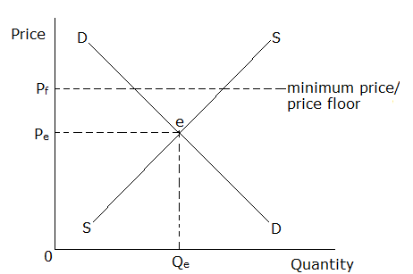

OPe = equilibrium price

OQe = equilibrium quantity demanded or supplied

OPc = minimum price/ price floor

**MERITS OF MINIMUM PRICE LEGISLATION**

1. Protects producers from exploitation by consumers through under charging. This basically applies to producers of agricultural goods. The buyers are not allowed to get produce from farmers at a price below the legislated price.
2. Increases output levels because it encourages more production in an economy hence economic growth and development.
3. Enables producers to realize stable incomes since it minimizes price fluctuations.
4. Minimizes consumption of harmful products such as alcohol, cigarettes, marijuana, etc. This is because the price is set above the equilibrium price hence making the products unaffordable by consumers.
5. Increases government revenue because the government is in position to charge reasonable taxes on profits received by producers.
6. May help an economy to offset economic depression or recession since it tends to activate investments/ production in the economy.
7. Minimizes smuggling of goods to other countries since producers are satisfied with home prices.
8. Increases employment opportunities as a result of increased production of commodities and trade in the economy.
9. Promotes research due to the high profits received by the producers which leads to production of better quality products hence better standards of living.

**DEMERITS**

1. Causes surplus output because of excess production hence wastage of resources.
2. Leads to increased costs of productionsince it is a high price and mainly set for primary products which form a major part of raw materials especially for agro – based industries.
3. A minimum price in form of minimum wage makes labour expensive forcing producers to opt for alternative methods of production instead of hiring expensive labour e.g. some producers start using more machines compared to men. This results into technological unemployment.
4. Leads to storage problems due to unmanageable surplus.
5. Leads to reduction in social welfare because of high costs of living.
6. Leads to over exploitation of resources which leads to exhaustion of some non-renewable resources like minerals.
7. Leads to smuggling of goods into the country making government to lose a lot of revenue required to meet its expenditure needs.
8. It is inflationary since there is no maximum. A minimum price makes it only illegal to set a lower price but sellers can set any price above it.
9. Widens income disparities between producers and consumers since it increases the profits of producers and expenditure of consumers.
10. It encourages dumping of commodities to other countries. Dumping has negative effects on the recipient country such as closure of local firms due to their out competition, under utilization of local resources among others.
11. Farmers are discouraged in the long run in case the government fails to buy the surplus output.

**NB:**

1. Dumping refers to the selling of a commodity in the external market at a lower price than the one charged in the local market.
2. Price support is where the government buys the surplus output on the market arising from the fixing of the minimum price.

ASSIGNMENT

1. Outline the objectives of maximum price legislation?
2. Under what circumstances may government employ a price control policy?
3. Examine the effects of price control in an economy.
4. Why may the use of price controls be avoided in an economy?

**CIRCUMSTANCES UNDER WHICH GOVERNMENT MAY EMPLOY A PRICE CONTROL POLICY**

A price control policy may be employed under the following circumstances.

1. When consumers are being exploited. In this case, the government fixes a maximum price.
2. When there is existence of monopoly and its consequences → maximum price.
3. When essentials of life are unaffordable to consumers → maximum price
4. When there is need to reduce income inequality → maximum price
5. When producers are being exploited → minimum price
6. When there is desire to attain higher levels of output (economic growth) → minimum price
7. When there is need to maintain industrial peace → minimum price
8. When there is need to stabilize producers’ incomes → minimum price
9. When there is need to offset an economic depression/ recession → minimum price
10. When government wants to discourage production and consumption of harmful products → both
11. When there are price instabilities → both.

**EFFECTS OF PRICE CONTROLS**

**POSITIVE EFFECTS**

1. Maximum price protects consumers from exploitation by producers through over charging.
2. Maximum price controls monopoly power.
3. Maximum price avails commodities to all groups of people in the economy.
4. Maximum price reduces income inequalities.
5. Maximum price widens consumers’ choice
6. Maximum price helps to increase on aggregate demand
7. Maximum price discourages importation of expensive commodities and encourages exports. This increases the foreign exchange earning of the country.
8. Minimum price protects producers from exploitation by consumers through under payment.
9. Minimum price increases output levels.
10. Minimum price enables producers to realize stable incomes.
11. Minimum price increases government revenue.
12. Minimum price may help an economy offset an economic depression or recession.
13. Minimum price increases employment opportunities.
14. Minimum price promotes research.
15. Price control maintains price stability
16. Price control checks on the production and consumption of harmful products.
17. Price control eliminates trade malpractices such as black marketing, smuggling of goods, etc.

**NEGATIVE EFFECTS**

1. Maximum price discourages entrepreneurship development.
2. Maximum price results into shortages.
3. Maximum price results into production at excess capacity.
4. Maximum price leads to unemployment due to reduced level of investments.
5. Minimum price causes surplus output hence wastage of resources.
6. Minimum price leads to increased costs of production.
7. Minimum price leads to storage problems due to unmanageable surplus.
8. Minimum price leads to reduction in social welfare because of high costs of living.
9. Minimum price leads to over exploitation of resources.
10. Minimum price causes inflation since there is no maximum.
11. Minimum price widens income disparities between producers and consumers.
12. Price controls encourage trade malpractices such as black marketing, smuggling, etc.
13. Price controls call for establishment of marketing boards which leads to exploitation of consumers.
14. Price controls lead to misallocation of resources due to distortion of price mechanism.
15. It is expensive for the government to enforce price controls.

**REASONS FOR AVOIDANCE OF PRICE CONTROLS**

1. Fear of causing trade malpractices such as smuggling, black marketing, etc. Maximum price legislation leads to smuggling of goods to other countries while minimum price legislation leads to smuggling of goods into the country.
2. Fear of raising costs of production which arise out of high costs of raw materials resulting from minimum price legislation.
3. Fear of causing unemployment resulting from maximum price legislation which forces firms to close down as they cannot cover their average costs.
4. To avoid unmanageable surpluses and storage problems in case of a minimum price.
5. To avoid discouraging entrepreneurs through tampering with their profit margins in case of a maximum price.
6. To avoid high administrative costs on these price controls e.g. price support.
7. To avoid unnecessary distortion of the price mechanism which may lead to misallocation of resources.
8. Fear of reducing social welfare of the people due to high cost of living caused by minimum price legislation.
9. To avoid underutilization of resources in case of a maximum price.
10. Fear of causing shortages of goods and services resulting from maximum price legislation which discourages production.

**AGRICULTURE IN RELATION TO DEMAND AND SUPPLY**

The nature of demand and supply in the agricultural sector tends to be unstable and this in turn tends to make prices of agricultural products fluctuate more often compared to the prices of industrial products or manufactured goods.

**AGRICULTURAL PRICE FLUCTUATIONS**

Agricultural price fluctuations refer to instabilities or changes in prices of agricultural products over a given period of time.

**CAUSES OF AGRICULTURAL PRICE FLUCTUATIONS **

1. **Divergence between planned output and actual output.**

When the actual output of farmers is greater than the planned output, over production arises leading to a fall in prices for the planned output. However where actual output is less than the planned output, there is shortage on the market hence causing the prices to increase.

1. **Long gestation period of agricultural products.**

The long gestation period of some crops makes supply to be inelastic. Before harvesting season, there is a shortage of agricultural products in the market and this leads to an increase in prices. However after harvesting, supply of agricultural products is increased on the market and this leads to a fall in prices being offered to producers.

**NB:**

Gestation period is the time it takes before new supplies of goods reaches the market for example maize takes 3-4 months while mushrooms take 1 month.

1. **Low income elasticity of demand for agricultural commodities.**

The demand for agricultural products is not influenced by changes in income i.e. changes in income have minimal impact on the demand for agricultural products. During seasons of high supply, surplus is created on the market and this leads to a fall in prices. However, a fall in supply leads to an increase in prices.

1. **Low price elasticity of demand (inelastic demand) for agricultural commodities.**

The demand for agricultural products is inelastic such that even if prices change, consumers demand almost the same quantities. This implies that change in supply is not followed by change in demand hence leading to continuous change in price levels i.e. surplus output pushes the prices downwards and shortages push the prices upwards.

1. **Changes in the costs of production.**

Farmers incur costs of production in form of buying seeds, fertilizers, farm equipments, hiring tractor services etc. When they incur high costs of production, they increase the prices for their products and when they incur lower costs of production, they reduce the prices hence price fluctuations.

1. **Perishability of agricultural products hence difficult to store.**

Most of the agricultural products are perishable and thus cannot be stored for future use. This causes prices to fall during harvesting periods because farmers tend to sell all their produce. On the other hand during non-harvesting periods, there is severe shortage because little or nothing was stored during the harvesting period and consequently prices go up.

1. **Bulkiness of agricultural products hence difficult to transport.**

Agricultural products are bulky and this makes them difficult to transport from production areas to market centres. This leads to a fall in prices at the production centres and a rise in prices at the market centres.

1. **Lack of co-operation among producers of agricultural products.**

Presence of many farmers competing amongst themselves makes it hard to regulate output in order to stabilize prices. When producers enjoy high prices of products in one season, many farmers are attracted to grow the same crop in the coming season. This results into massive output leading to a fall in prices. When producers make losses, many farmers are discouraged and stop growing the crop. This results into shortages in the next season forcing prices to rise.

1. **Heavy dependence on nature/ effects of changes in natural factors like weather, soils, etc which affect output levels.**

Unfavourable climatic factors like prolonged droughts, floods, pests and diseases in some seasons result into low output leading to an increase in the price of agricultural products. On the other hand, favourable climatic conditions lead to greater output by the farmers resulting into declining prices of agricultural products.

1. **Substitution of agricultural raw materials with artificially made raw materials by developed countries/ high competition from synthetic/ artificial fibres.**

Some agricultural products like cotton face stiff competition from synthetic fibres like nylon, silk, polyester, etc. Where buyers prefer synthetic fibres to natural fibres, the price of natural fibres falls. However, when the demand for synthetic fibres declines, buyers resort to natural fibres and their prices increases.

1. **Introduction of raw material saving techniques by developed countries (major buyers).**

Raw material saving innovations have tended to interfere with planning output in the agricultural sector thereby causing instabilities in supplies and hence instabilities in prices of agricultural products.

1. **Weak bargaining position of LDCs on the world market/ external determination of prices**

The major buyers (MDCs) dictate the prices of agricultural products like coffee, cotton, tea etc. As a result, LDCs cannot secure stable prices for their products because the major buyers increase and decrease the prices since they are more or less price makers in the foreign markets hence price fluctuation.

1. **Agricultural products are only minor inputs in the manufacturing sector.**

The agricultural products used as inputs in the production of industrial products form a small part. E.g. in the manufacturing of cars, agricultural products are only used in the making of tyres making their demand inelastic.

1. **Poor surplus disposal system/ machinery.**

Developing countries are faced with a problem of poor infrastructure such as underdeveloped transport facilities making it difficult to transport the surplus to areas of scarcity. This leads to a fall in prices in the areas where there is surplus output and a rise in prices in areas of scarcity.

**EFFECTS OF AGRICULTURAL PRICE FLUCTUATIONS ON AN ECONOMY**

1. **Price fluctuations lead to fluctuations in farmers’ incomes.**

Incomes of farmers increase when prices increase and they decrease when the prices decrease.

1. **Price fluctuations result into fluctuations in government revenue.**

This is because government receives most of the revenue from taxing income and/ or property. Therefore fluctuation in income means fluctuation in tax revenue.

1. **Fluctuations in prices of major export crops lead to instability in export earnings.**

In seasons when export prices increase, export revenue for the government increases. However in seasons when export prices fall, export revenue also declines. This causes unstable export earnings from one season to another.

1. **Government planning based on expected earnings from the agricultural sector becomes difficult.**

When prices are fluctuating, it is not easy to predict what is to be earned from selling agricultural products. This complicates planning by the government in case the plans are to be financed by incomes from the agricultural sector/ agricultural exports.

1. **Farmers get discouraged/ frustrated.**

This leads to subsistence production hence a decline in economic growth and development.

1. **Price fluctuations lead to rural urban migration with its negative consequences.**

As incomes from agriculture become unreliable, the frustrated farmers (especially the young and energetic) migrate to urban areas looking for better employment avenues/ opportunities. Unfortunately, this migration is associated with many problems like open urban unemployment, high crime rate, development of slums, gambling, etc.

1. **Price fluctuations lead to instability in exchange rates.**

As export prices of agricultural products increase, a country’s foreign exchange earnings are improved. This results into greater foreign exchange inflow. This increased inflow of foreign currency results into a fall in exchange rates in the country. However, a fall in export prices of agricultural products creates a shortage of foreign currency in the country. This results into an increase in exchange rates.

1. **Price fluctuations lead to instabilities in balance of payments.**

An increase in export prices of agricultural products in a given season results into an improvement in the balance of payments position.On the hand, a fall in export prices of agricultural products in a given season results into worsening of the balance of payments position.

1. **Price fluctuations result into unstable/fluctuating terms of trade.**

When prices of agricultural exports increase, the terms of trade improve (become better). However when export prices decline, the terms trade deteriorate (become worse).

1. **Investment in agriculture becomes uncertain**.

This causes speculation as farmers regard investment in agriculture as a gamble and thus irrational use of land.

1. **Price fluctuations lead to seasonal unemployment in the sector.**

Some farmers may decide not to produce in a particular season because of the miserable prices obtained in the past season. Such farmers become seasonally unemployed.

1. **Price fluctuations worsen income inequalities.**

A decline in prices of agricultural products in some seasons makes farmers to earn less income than individuals employed in other sectors like the industrial sector, service sector, etc.

**ASSIGNMENT**

Why is there need to stabilize agricultural products?

**POSSIBLE WAYS OF STABILISING AGRICULTURAL PRICES**

1. **Through operation of the buffer stock policy.**

A buffer stock policy is one whereby the government through the market boards buys the surplus output from farmers, stores it and sells it during periods of scarcity. This helps to iron out fluctuations in supply, prices and incomes.

1. **By use of the stabilization fund policy.**

A stabilization fund policy is the deliberate attempt by the government of paying the producers less than the market price when prices and incomes are high and putting the realized difference into a fund and later using the fund to pay the producers higher prices than the market price when prices and incomes are low to avoid fluctuations in prices and incomes as would be dictated by the market forces.

1. **Improving on storage facilities/ system**

For example use of fridges to ensure proper storage of highly perishable products like milk, fish, tomatoes etc. This stabilizes supply and hence prices and incomes of agricultural producers.

1. **Improving on transport system.**

This involves construction of feeder and main roads linking production centres and market centres. A better transport system evens out surpluses by easing transportation of goods from production centres (areas of plenty) to market centres (areas of scarcity) thereby stabilizing prices of agricultural products.

1. **Modernizing agriculture/ improvement in technology and carrying out extensive research.**

This not only improves on the quality of agricultural products but also leads to a reduction in their gestation period. For example use of hybrid seeds with a short gestation period, taming nature through irrigation, etc. All these stabilize supply leading to stable prices over time.

1. **Setting up agro-based industries.**

Agro-based industries add value onto agricultural products. This helps to improve on the quality and prices of agricultural products.

1. **Joining international commodity agreements.**

International commodity agreements like international coffee agreement help to fix prices and quotas for the buyers and sellers of commodities to avoid fluctuations of prices on the world market resulting from excess supply.

1. **Diversifying agriculture.**

It is important to note that many developing countries depend on only one or two crops for export. As a result, fluctuations in the output or prices of the crop(s) may cause considerable instability in exports and incomes of those countries. To reduce the effects of dependence on one or a few crops, there is need to produce a variety of crops so that failure of one can be compensated for by the successful harvest of the other(s).

1. **Development of forward (future) markets/ contract trade**

This involves producers and buyers signing agreements specifying the amount, quality and price of a given commodity to be supplied in the future. In this way, changes in supply do not affect the price agreed upon hence stability in prices of agricultural products. Future trade can be arranged for both local and foreign trade.

1. **Through price legislations.**

The government of the concerned economy can carry out price controls by fixing prices of selected commodities.

1. **Formation of co-operatives to control supply.**

Co-operatives help to educate the farmers about the use of better farming methods, looking for market for the farmers’ output, regulating supply through a quota system, improving the bargaining abilities of farmers with buyers, etc. All these actions help to stabilize the prices of agricultural products.

1. **Strengthening regional economic integration.**

This improves the bargaining power of member states for their agricultural exports on the world market.

1. **Diversifying and expanding the markets for agricultural products.**

This involves extending and widening markets for agricultural products. It is done by searching for new buyers from other developing countries in Asia and in other parts of Africa.

1. **Re-sale price maintenance system.**

It is important to note that greater fluctuations are at times caused by middlemen and if prices at which consumers are to buy are set in advance by the primary producers, instability in prices may be minimized.

1. **Subsidising farmers/ providing tax incentives to farmers/ stabilising costs of production.**

This involves reducing taxes on farm inputs or provision of subsidies to farmers on farm inputs. This helps to stabilise costs of production and ensure stable supply and prices.

1. **Providing affordable credit to farmers to buy necessary inputs.**

This involves providing low interest loans to farmers through the local SACCOs and commercial banks to enable purchase of farm inputs. This leads to stable supply of agricultural products and thus stable prices.

**EFFECT OF A CHANGE IN SUPPLY UNDER CONDITIONS OF INELASTIC DEMAND**

With inelastic demand, small change in supply can have a large impact on changing price.

Illustration

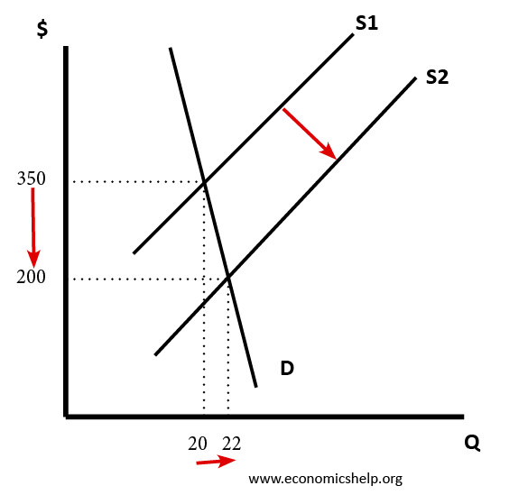

From the diagram above, it can be observed that a small increase in supply (represented by a shift of the supply curve to the right from S1S1 to S2S2) leads to a big fall in price from P2 to P1. Note that a fall in supply has a similar but opposite effect.

**THE COBWEB THEORY**

The cobweb theory is an economic model that attempts to explain the occurrence of price fluctuations in certain types of markets.

The cobweb theory is based on a time lag between supply and demand decisions. Since agricultural marketsare characterised by a time lag between planting and harvesting, the cobweb model can be applied to explain the occurrences of agricultural price fluctuations.

Because of this time lag, the output produced in a particular season is determined by the prices of the previous season.

Illustration of the cobweb model (Convergent cobweb)

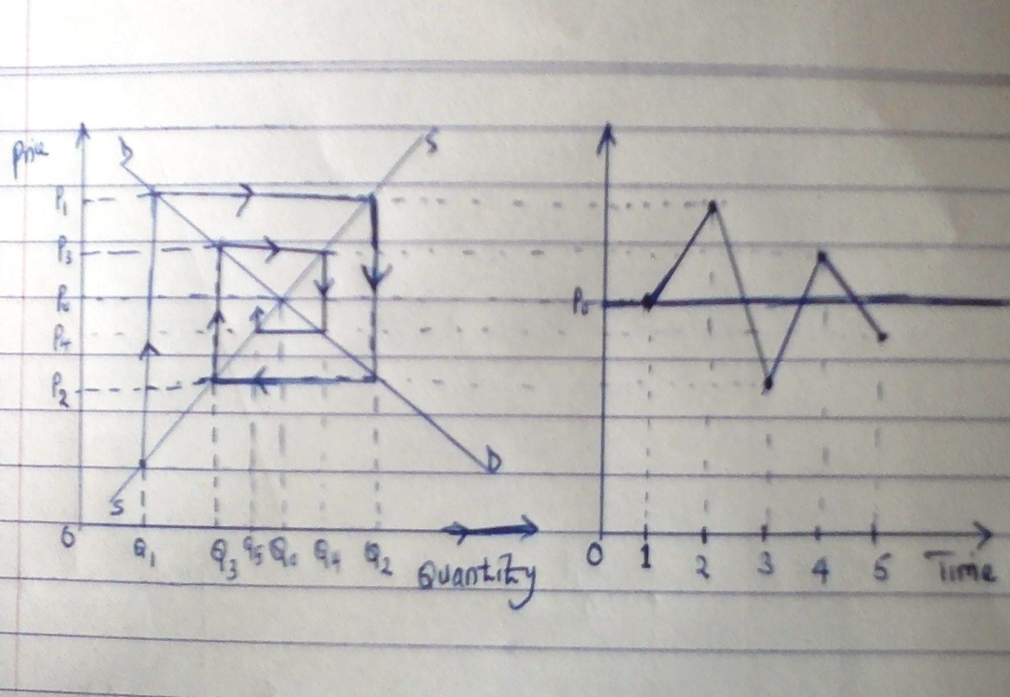

From the above illustration, initially the equilibrium quantity supplied is OQoand the equilibrium price is OPo.

Assuming there is a shock in an economy for instance an unexpectedly bad weather, this will result in a fall in the amount of the commodity supplied on the market from OQo to OQ1 (A shortage is created). This results into an increase in the price of the commodity from OPo to OP1. This increase in the price above equilibrium attracts new farmers to plant the same crop and also makes the old farmers to plant more. Because of the time lag between planting and harvesting, much will be supplied in the next season i.e. output increases from OQ1 to Q2 (There is surplus output). This forces the farmers to reduce the prices of their products from OP1 to OP2. This fall in price discourages some farmers and they stop growing the crop and even those who remain in production end up planting less. This results into less output put on the market the next season (Quantity OQ3 is supplied which is less than demand) again forcing prices to rise from OP2 to OP3. This process will go on until equilibrium is reached after a number of oscillations.

From the illustration, it can be observed that the fluctuations spiral inwardly meaning that the forces of demand and supply work out to restore the equilibrium conditions. This is a case where demand is more elastic than supply (The supply curve is steeper than the demand curve)